Emergency Department Overcrowding and Factors that Contribute to Ambulance Diversion

Abstract
Ambulance diversion is a controversial and potentially harmful method used by hospitals to address emergency department overcrowding. Using emergency department utilization data from hospitals in California, we investigated factors significantly associated with ambulance diversion hours. We created a three-way multilevel model with time, hospital, and county level variables and found that time, the number of admitted patients, and emergency medical service (EMS) level were significantly associated with increased diversion hours. The implications of these results are twofold. First, these factors suggest that ambulance diversion is becoming a more pronounced problem over time. Second, the level of EMS services offered at an emergency department and inpatient volume constraints are significant contributors to ambulance diversion.

Introduction
Emergency department overcrowding continues to be a problem in Western healthcare systems as the need for emergency and critical care increases (Cowan & Trzeciak, 2005). Emergency department (ED) overcrowding is defined as an extreme volume of patients in the ED and a pressure to operate beyond its capacity (Schull, Lazier, Vermeulen, Mawhinney, & Morrison, 2003). ED overcrowding jeopardizes patient health because it causes longer wait times, delayed treatment of the critically ill, decreased patient satisfaction, and eventual walkouts without treatment (Tuller, 2016; Shen & Hsia, 2011). One response to ED overcrowding is ambulance diversion, which is when a hospital closes its doors and instates “diversion status.” Consequently, ambulances must bring patients to a nearby, alternative hospital. Our research explored the factors associated with the number of ambulance diversion hours for hospitals that divert ambulances using multi-level statistical modeling.

Methods
The data came from the California Office of Statewide Health Planning and Development and contained information on emergency department utilization for all hospitals in California from 2007 to 2015. The original dataset had 4,508 entries with 31 variables. The dataset included the number of diversion hours (our response variable), and other explanatory variables of interest, including the year of the observation, the county in which the hospital is located, the total number of Emergency Medical Service (EMS) patient visits, the total number of admitted patients, EMS level, trauma level of the hospital, and the number of ED beds/stations at each hospital.
We filtered out hospital observations that did not have an emergency department and selected observations within the years 2013, 2014, and 2015 to examine data from the three most recent available years. Before the modeling process began, several variables were scaled and filtered to improve interpretability and to satisfy the normality assumption. This included logging our response variable, diversion hours. Our final dataset consisted of 450 observations.
ED overcrowding is a complicated issue that can derive at many stages of the patient care process, from the time a patient is picked up by an ambulance, to their admittance or dismissal from a hospital. To address the many levels of ambulance diversion, a three-way multilevel modeling method was conducted using the glmer package in R. Time was the observational unit at level one, measured in years, individual hospitals at level two, and county at level three. The level one covariates considered were the number of patients admitted, the total number of visits, and time. The level two covariates considered were EMS level, the number of ED stations, and the trauma level at each hospital. There were no level three covariates. At level three, error terms were considered only on the intercept. A Likelihood Ratio Test (LRT) was used as the model selection criteria to compare null (reduced) and alternative (full) models. A p-value less than 0.05 was deemed significant and the alternative model was chosen over the null. Lastly, due to the nature of multilevel modelling and the limitations of the glmer package, individual covariates were deemed significant with a t-value greater than 2.00 (Roback & Legler, 2019).

Results
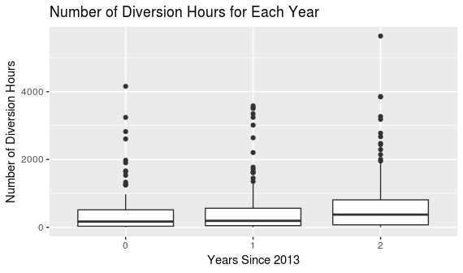
Overall, data was included on 344 different hospitals. For these hospitals, the mean number of patient EMS visits from 2013 to 2015 was 40,010.86. The mean number of admitted patients, however, was only 5,489.3, indicating that many patients may have been non-emergent cases, transferred to a different facility, or not treated at all.
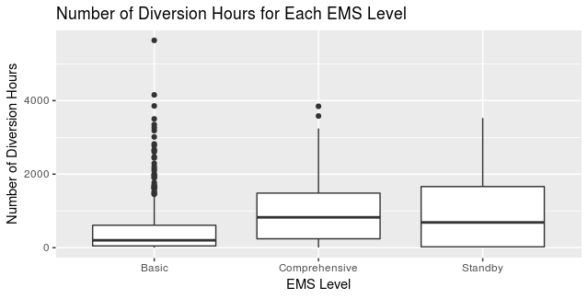
Our model (Table 1) demonstrates that the mean number of diversion hours for all hospitals in all counties with zero admitted patients and a basic EMS level in the year 2013 was 23.90 hours (ɑ₀). The parameter for the year variable indicates that for each additional year, mean diversion hours for all hospitals across all counties increases by 46.3%, after adjusting for the number of admitted patients and EMS level (Figure 1). Moreover, for every additional 1000 patients admitted to any hospital across all counties, the mean number of diversion hours increases by 7.71%, after controlling for years since 2013 and EMS level. When an EMS level is comprehensive, mean diversion hours changes by a factor of 3.854, in comparison to basic EMS level, after adjusting for years since 2013 and the number of admitted patients. Finally, when an EMS level is standby, the mean diversion hours changes by a factor of 5.422, in comparison to basic EMS level, after adjusting for years since 2013 and number of admitted patients (Figure 2).
Figure 2: Diversion Hours by EMS Level.

Figure 1: Diversion Hours by Year Since 2013.

Table 1: Parameters for Final Three-way Multilevel Model. Exponentiated values used for interpretations. *Denotes significant t-values.

 | Estimate | exp(Estimate) | Std. Error | t-value
(Intercept) | 3.17390 | 23.90051 | 0.33227 | 9.552*
Year (year2013) | 0.38066 | 1.46325 | 0.06364 | 5.981*
# of Admitted Patients (admit1) | 0.07426 | 1.077087 | 0.02798 | 2.654*
Comprehensive EMS level | 1.34910 | 3.853955 | 0.61857 | 2.181*
Standby EMS level | 1.69058 | 5.422625 | 0.90733 | 1.863

Discussion
Our modeling process reflected that the factors significantly associated with the number of ambulance diversion hours for all hospitals that divert in California include the year, the number of admitted patients, and the EMS level. First, the positive estimate of the year variable indicates that ambulance diversion is increasing with each additional year, consistent with several studies regarding the increasing prevalence of ED overcrowding (Patel, Derlet, Vinson, Williams, & Wills, 2006; Li, Vanberkel, & Carter, 2018). The number of admitted patients was also positively associated with the number of diversion hours. Patient admittance could indicate the severity of patients to the ED or the amount of resources, including time and money, that are allocated to patients in the ED. As the number of admitted patients increases, the number of inpatient hospital beds will decrease and there will be fewer beds to place admitted patients from the ED, potentially explaining the positive relationship between admitted patients and diversion hours.
Moreover, our models showed that facilities that offer comprehensive and standby EMS services were positively associated with diversion hours. Comprehensive ED’s provide the most extensive services; thus, it is likely that ambulances bring more complex and demanding patients to emergency departments that offer these services. Consequently, the time and resources required to handle these patients, including admitting them to an inpatient ward, could necessitate more diversion hours for these departments in comparison to departments offering basic services. Furthermore, standby EMS emergency departments do not have an emergency physician staffed 24-hours a day. Lack of a 24-hour physician staff in these departments could lead to more diversion hours because there are no staff members available to attend to a patient.
The limitations to our analysis include generalizability and confounding variables. First, our analysis included hospitals in California over the discrete 2013 to 2015 time period. With this, the conclusions we make are extended to only those hospitals in California that have information on our model variables, such as EMS level designation. Second, there is a limitation associated with confounding variables, such as patient demographics, that were omitted from this analysis. For example, elderly and acutely ill patients require more resources and could be diverted more often than other demographics.
Nevertheless, our model underscored significant factors that were associated with increased ambulance diversion hours, including time, the number of admitted patients, and the EMS level. Future studies conducted by health services and operational researchers should explore and target how these specific factors may be addressed to decrease the number of ambulance diversion hours. These studies could include information from other years and states to extend generalizability. Additionally, these studies could incorporate patient outcomes or measurements of cost in relation to ambulance diversions. Such an inclusion would provide insight into whether or not ambulance diversion is being used as a cost shielding tactic for a hospital, rather than solely as a technique to address ED overcrowding. Lastly, additional patient level information could be useful in considering the effects of outbreaks, access to primary care, and other demographics that, as mentioned above, may be confounders in our analysis.
References

Cowan, R., & Trzeciak, S. (2005). Clinical review: Emergency department overcrowding and the
potential impact on the critically ill. Critical Care, 9(3), 291-295. DOI: 10.1186/cc2981

Li, M., Vanberkel, P., & Carter, A. J. (2018). A review on ambulance offload delay literature. Health care management science, 1-18.

Patel, P.B., Derlet, R.W., Vinson, D.R., Williams, M., & Wills, J. (2006). Ambulance diversion reduction: The Sacramento solution. The American Journal of Emergency Medicine, 24(2), 206-213. DOI:10.1016/j.annemergmed.2004.07.066.

Roback, P., & Legler, J. (2019). Broadening Your Statistical Horizons.

Schull, M.J., Lazier, K., Vermeulen, M., Mawhinney, S., & Morrison, L.J. (2003). Emergency department contributors to ambulance diversion: A quantitative analysis. Annals of Emergency Medicine, 41(4), 467-476. DOI:10.1067/mem.2003.23.

Shen, Y. C., & Hsia, R. Y. (2011). Association between ambulance diversion and survival among patients with acute myocardial infarction. JAMA, 305(23), 2440-2447.

Tuller, D. (2016). Ambulance diversion: Efforts to mitigate ambulance diversion have been
effective, but questions remain for future progress. Health Affairs, 1-5. DOI:
10.1377/hpb20160602.353150

Appendix

Table A1: Variable Chart with name, new variable name, and the role, type, values and units of the variable
Name | New Variable Name | Variable Role | Type | Values | Units
Total Diversion Hours | diverthours | response | numeric | 0 - 5460 | hours
Ambulance Diversion Reported | divert | response | binary | 0 = No  1 = Yes | n/a
COUNTY | county | explanatory | categorical | character | n/a
OSHPD_ID | id | observational unit | categorical | n/a | n/a
Trauma Ctr Designation | trauma | explanatory | categorical | 0=None  Level I, II, III, IV | n/a
EMS Level December 31st | emslevel | explanatory | categorical | Standby  Basic  Comprehensive | n/a
EMS Visits Total | totalvisits | explanatory | numeric | 0 - 168351 | total visits
EMS Visits Total - Admitted | admit | explanatory | numeric | 0 - 35199 | total admitted visits
EMS Treatment Stations | stations | explanatory | numeric | 0-106 | treatment stations

Figure A1: Frequency plot of the distribution of the natural log of diversion hours with values of 0 removed representing the density of log diversion hours that are not 0.
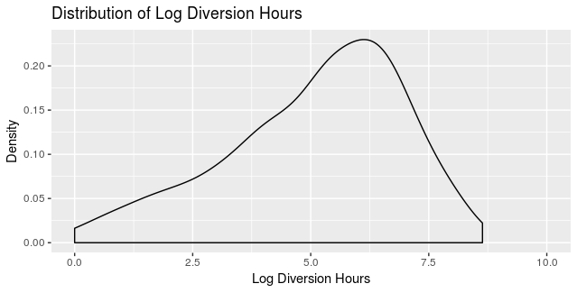

Equation A1: Three-way multilevel model with year as level one, hospital as level two, and county as level three.
