08
Fall
Predicting Tooth Loss from North Carolina Behavioral Risk Factor Surveillance Survey Data

Tooth loss has far reaching circumstances for individuals’ overall health and quality of life, thus it is of interest to determine behavioral factors that predict tooth loss. Here BRFSS data was used to construct a logistic model to predict tooth loss, controlling for demographic factors known to affect tooth loss. Out of the behavioral variables of smoking, difficulty doing errands alone, time since last dental office visit, and whether a person was in a relationship, only smoking was a significant predictor of tooth loss. Further investigation of what kind of smoking behavior (how many years, packs per day, etc.) contributes significantly to tooth loss should be investigated, as well as determining if other behavioral variables from BRFSS data predict tooth loss.
Introduction. Tooth loss has several effects on general health. Having fewer than 9 teeth can impact quality of life more than cancer, hypertension, or allergies¹. Tooth loss impacts nutrition since it restricts the type of foods an individual can eat². With fewer than 25 teeth, individuals eat fewer vegetables and fiber while eating more saturated fat, cholesterol and calories³. Individual’s awareness of their tooth loss can affect their comfort in public, which can compel them to smile and laugh less, feel less confident, and avoid forming close relationships⁴. Researchers have studied factors that predict tooth loss to inform interventions that decrease tooth loss.
Studies predicting tooth loss provide mixed results. Some studies in geriatric populations report that their models do not have much predictive power^{5,6}. Locker et al. showed that factors such as gender, marital status, self-reported oral health status, the number of decayed root surfaces, and mean periodontal attachment loss of 4 mm or more were the best predictors of tooth loss, but even these factors together were reported to be an ineffective model⁵. Other studies indicate that gender and type of tooth impacted the likelihood of tooth loss⁶, or that preexisting dental conditions (for example, leftover root tips from a previously lost tooth or gum disease), smoking and infrequent brushing are associated with tooth loss⁷. The varied results and significant terms in these studies suggest that there are not many consistently significant predictors of tooth loss across different groups. These studies suggest that several variables exist that may be predictors of tooth loss worthy of investigation for any population.
As a potential future dental practitioner in North Carolina, it is of interest to me to determine if the behavioral factors used in prediction of tooth loss in other populations are effective in predicting tooth loss due to decay for North Carolina adults. In this paper I seek to determine if behavioral data from the Behavioral Risk Factor Surveillance Survey can predict tooth loss, controlling for demographic factors. The CDC acknowledges that oral health differences exist on the basis of race, socioeconomic status, gender, age, geographic location, and access to consistent dental insurance⁸. As such, I will include these factors as control variables in my logistic regression model.
Methods. The source of the data for this project is from the 2016 North Carolina Behavioral Risk Factor Surveillance Survey, or BRFSS⁹. BRFSS data is collected by calling random phone numbers (cellphones and landlines) within each state and then interviewing a randomly selected adult in the household. The CDC then weights this random sample to improve representativeness by state. A table comparing 2010-2017 NC Census statistics¹⁰ to the 2016 weighted NC BRFSS data is presented in the Appendix. The NC BRFSS data is reasonably representative of NC adults, though NC BRFSS overrepresents individuals over age 64 by about 11% compared to the NC census, and underrepresents Hispanic individuals by 6%.
The variables investigated in this report are summarized in Table 1, with their recoded definitions and responses.

Variable Name | Definition | # misssing |  | Responses
LastAppt | Time since respondent last visited a dentist for any reason. | 63 | <12 months, >12 months.
TeethRemvd | Number of respondent’s teeth have been removed because of tooth decay, infection, or gum disease. | 97 | No teeth lost, or at least one tooth lost
Sex | Sex of the respondent. | 2 | Male or Female.
Age | Age of respondent | 0 | 18 to 99 yrs.
Race | Race of respondent | 51 | White, Black, Nat. American, Asian, Nat. Hawaiian or P.I., Hispanic, Other.
InRelationship | Indicates relationship status of respondent. | 15 | In a relationship (married or member of an unmarried couple), or not in a relationship (divorced, widowed, separated, never married).
Diabetes | Whether or not a person has diabetes. | 9 | Yes or No (No includes diabetes only during pregnancy and pre-diabetes or borderline diabetes)
Pregnancy | Whether or not a respondent was pregnant. | 5249 | Yes or No.
Smoker | Whether or not a person has smoked at least 100 cigarettes (5 packs) in their entire life. | 172 | Yes or No.
GenHealth | A person's rating of their general health. | 18 | 5=Poor, 4=Fair, 3=Good, 2=Very Good, 1=Excellent.
Income | Annual Income from all sources. | 1124 | Low, (<$10,000 to <$35,000), Middle ($35,000 to <$75,000), high (>$75,000)
DiffAlon | Measures if respondent has difficulty doing errands alone, due to a physical, mental or emotional condition. | 145 | Yes or No.
Edu | Highest level of education pursued. | 9 | No HS Degree (<12th grade), HS Grad (12th grade, GED or some college), College Grad (4 years of college)
Healthcare | Indicates if the respondent has access to health insurance of any kind (not necessarily dental insurance). | 20 | Yes or No.
Table 1. Names, definitions, missing observations and responses for variables of interest.

Because the response variable is binary, logistic regression was used for modeling. To investigate associations between tooth loss and each variable of interest, tables of conditional proportions and single variable logistic regression models were constructed. Age had to be log transformed to achieve linearity of the empirical logit plot. A race variable was created by combining the responses from X_PRACE1 and HISPANC3 from BRFSS data. Initially all values were assigned from X_PRACE1, then if a respondent gave 1, 2, 3, 4 or a value greater than 9 for the HISPANC3 entry, they were recorded as Hispanic. Results of single variable models informed the multiple logistic regression models, which were created by sequentially adding the most significant predictors (based on p-value) from the single variable logistic models, performing drop in deviance tests, and then checking changes in misclassification rates; If a term did not improve the misclassification rate more than about 0.005%, the term did not contribute meaningfully to the model.
Results. Of the 6356 individuals included in this survey, 53% of NC adults have lost at least one tooth to decay. Race, age, income level, health insurance, education level, relationship status, having diabetes, being a smoker, time since last dental appointment, and difficulty doing tasks alone were all individually significant predictors of tooth loss. Pregnancy and sex were insignificant at any level. Following the modeling procedure described in Methods, the final model is in Table 4. Misclassification rates for this model indicate that the false positive rate for tooth loss was 14.0%, and the false negative rate for tooth loss was 11.3%.

Term |  | Coefficient, 95% CI |  | p-value |  | Interpretation (assuming all other variables held constant)
Intercept | -11.698, (-12.67, -10.74) |  | <2E-16 |  | No interpretation.
Income(Low) | 0.952, (0.766, 1.14) |  | <2E-16 |  | The odds of losing at least one tooth for a low-income person are 2.59 fold greater than for a person with high income.
Income(Middle) | 0.599, (0.427, 0.821) |  | 1.04E-11 |  | The odds of losing at least one tooth for a middle-income person are 1.82 fold greater than for a person with high income.
Edu(HS Grad) | 0.753, (0.601, 0.906) |  | <2E-16 |  | The odds of losing at least one tooth for a high school graduate is 2.12 fold greater than for a person with a college degree.
Edu(No HS Degree) | 1.426, (1.13, 1.73) |  | <2E-16 |  | The odds of losing at least one tooth for a person with no high school degree is 4.16 fold greater than for a person with a college degree.
Log(Age) | 2.83, (2.62, 3.04) |  | <2E-16 |  | Doubling the age of a person is associated with a change in odds by a multiplicative factor of 7.11.
Smoker(Yes) | 0.628, (0.492, 0.764) |  | <2E-16 |  | The odds of losing at least one tooth for a smoker is 1.87 fold greater than for a person who does not smoke.
Sex | 0.0125, (-0.121, 0.147) |  | 0.855 |  | (NS) The odds of losing at least one tooth for a man are 1.25% greater than that of a woman.
Healthcare(Yes) | -0.145, (-0.369, 0.078) |  | 0.204 |  | (NS) The odds of losing at least one tooth for a person with access to some healthcare insurance is 86.5% that of a person with no healthcare insurance.
Race(Black) | 0.164, (-0.412,0.757) |  | 0.582 |  | (NS) The odds of losing at least one tooth for an African American are 17.8% greater than that of an Asian person.
Race(Hispanic) | -0.160, (-0.815,0.507) |  | 0.633 |  | (NS) The odds of losing at least one tooth for a Hispanic person are 85.2% that of an Asian person.
Race(Nat. Amer.) | -0.286, (-1.01,0.451) |  | 0.441 |  | (NS) The odds of losing at least one tooth for a native American are 75% that of an Asian person.
Race(Nat. Hawaiian or PI) | -0.559, (-2.060,0.877) |  | 0.451 |  | (NS) The odds of losing at least one tooth for a Native Hawaiian or Pacific Islander are 57% that of an Asian person.
Race(Other) | -0.423, (-1.07,0.234) |  | 0.202 |  | (NS) The odds of losing at least one tooth for a person of some other race are 65.5% that of an Asian person.
Race(White) | -0.636, (-1.198, -0.0572) |  | 0.819 |  | (NS) The odds of losing at least one tooth for a white person are 52.9% that of an Asian person.
Table 2. The final multiple logistic regression model predicting tooth loss, with controlling and significant variables. Coefficients, 95% confidence intervals, p-values and interpretation of slopes included. Interpretation of each variable assumes all other variables are held constant. NS=Not Significant.

Discussion. The purpose of this paper is to identify behavioral factors that predict tooth loss for NC adults. Controlling for income, education, age, race, sex and access to health insurance, I found smoking was the only behavioral variable that changed misclassification rates enough to merit inclusion in the model (Table 2). This is consistent with the work of Slade⁷, who found smoking was a significant predictor of tooth loss. Sex and marital status were not found to be significant predictors, contrary to the results reported by Hand⁶ and Locker⁵. The implications of this research are aligned with the current practices of dentists: dentists should encourage patients to quit smoking, and follow best practices for smoking intervention.
The results of this paper are generalizable to North Carolina adults, although recall that the BRFSS sample overrepresents the number of individuals aged 65 and over and underrepresents Hispanic individuals in North Carolina. The binary variable for tooth loss (TeethRemvd) does not capture much information about what teeth or how many teeth were lost, which would be valuable information in determining how these results are relevant to overall health outcomes. Some variables have very broad definitions that make it difficult to discern their impact, as in the case of the smoker term (Table 1). Smoking more than 100 cigarettes in one’s lifetime was assumed to mean that an individual has a current or past history of frequent smoking; however, an infrequent smoker could still report smoking over 100 cigarettes in their life. It is not clear at what point smoking becomes detrimental to oral health; effects may depend on the frequency of smoking within a certain time frame. Also, not all behavioral variables from BRFSS were studied: only smoking, difficulty doing errands alone, time since last dental office visit, and relationship status. As such, it may be the case that smoking is not the most significant behavioral predictor of tooth loss, only the most significant of the four predictors examined. Many other behavioral predictors need to be investigated, such as sleep and exercise habits, alcohol consumption and use of other tobacco or vaping products. Data on some of these questions are available through BRFSS; a natural next step would be to continue the analysis conducted here using the other behavioral predictors available in the BRFSS data.

Works Cited

1. Mack F, Schwahn C, Feine JS, Mundt T, Bernhardt O, John U, Kocher PT, Biffar R. “The impact of tooth loss on general health related to quality of life among elderly Pomeranians: results from the study of health in Pomerania (SHIP-O)”. Int J Prosthodont, Volume 18, 2005, pp. 414–419.
2. Chauncey HH, Muench ME, Kapur KK, Wayler AH. “The effect of the loss of teeth on diet and nutrition.” Int Dent J. Volume 34, no. 2, 1984, pp. 98-104.
3. Joshipura, K. J., Willett, W. C., Douglass, C. W.. “The impact of Edentulousness on Food and Nutrient Intake.” The Journal of the American Dental Association, Volume 127, no. 4, 1996, pp 459-467.
4. Davis, D M, et al. “Prosthetics: The Emotional Effects of Tooth Loss: a Preliminary Quantitative Study.” British Dental Journal, Volume 188, 2000, pp. 503-506.
5. Locker, D., et al. “Incidence of and Risk Factors for Tooth Loss in a Population of Older Canadians.” Journal of Dental Research, Volume 75, no. 2, Feb. 1996, pp. 783–789,
6. Hand, J. S., Hunt, R. J. and Kohout, F. J..“Five‐year incidence of tooth loss in Iowans aged 65 and older.” Community Dentistry and Oral Epidemiology, Volume 19, 1991, pp 48-51.
7. Slade, G. D., Gansky, S. A. and Spencer, A. J.. “Two‐year incidence of tooth loss among South Australians aged 60+ years.” Community Dentistry and Oral Epidemiology. Volume 25, 1997, pp. 429-437.
8. “Disparities in Oral Health.” Centers for Disease Control and Prevention, Centers for Disease Control and Prevention, 15 Mar. 2018. www.cdc.gov/oralhealth/oral_health_disparities/index.htm
9. “Behavioral Risk Factor Surveillance System.” Centers for Disease Control and Prevention, Centers for Disease Control and Prevention, 4 Sept. 2018, www.cdc.gov/brfss/index.html
10. “U.S. Census Bureau QuickFacts: North Carolina.” Census Bureau QuickFacts, United States Census Bureau, 2018, www.census.gov/quickfacts/nc.

Appendix

Comparison Category | US Census 2010-2017¹⁰ | BRFSS 2016
Age (% >64 yrs) | 15.9 | 27.2
Gender (% F) | 51.3 | 54.4
Race (% White, Black, Native American, Asian, Nat. Hawaiian or PI, Hispanic) | 70.8, 22.2, 1.6, 3.1, 0.1, 9.5 | 67.8, 19.9, 2, 1.5, 0.2, 3.7
Education Level (% HS Grad, College Grad) | 57.3, 29 | 56.5, 32
Health Insurance (% with none, age <65 yrs) | 12.60 | 16.30

Table A1. Comparisons between the NC 2016 BRFSS individuals and the NC 2010-2017 census.

Variable | Proportion of NC Adults
Tooth Loss (at least one) | 0.532
Last Appointment (>12 months) | 0.355
Sex (F) | 0.544
Age (> 64) | 0.272
Race (Asian, Black, Hispanic, Nat. Amer., Nat. Hawaiian or PI, White, Other) | 0.015, 0.200, 0.037, 0.021, 0.002, 0.04, 0.684
Relationship Status (in relationship) | 0.537
Diabetes (Yes) | 0.137
Pregnant (of women, Yes) | 0.031
Smoker (Yes) | 0.450
General Health (Poor, Fair, Good, Very Good, Excellent) | 0.060, 0.142, 0.315, 0.313, 0.171
Income Level (Low, Middle High) | 0.426, 0.304, 0.270
Difficulty Doing Errands Alone (Yes) | 0.079
Education Level (No HS, HS Grad, College Grad) | 0.111, 0.566, 0.323
Health Care Coverage (Yes) | 0.881

Table A2. Proportion of individuals within variable categories considered in model.

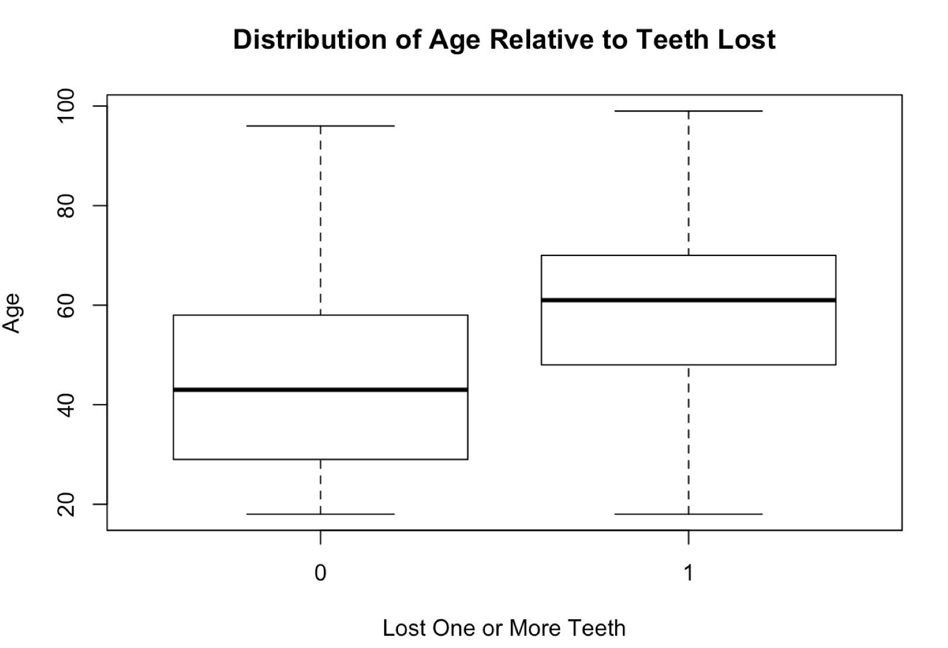
Table A3. Age distribution of NC Adults relative to whether or not they have lost teeth to decay.

Model | Terms | P-Values | Interpretation of one coefficient
Sex | 0.139-0.0189(SexMale) | 5.05E-05, 0.709 | (NS) The odds of losing at least one tooth for a man are 1% greater than for a woman.
Race | -0.661 + 1.263(Black) + 0.628(Hispanic) + 1.048(Native American) + 0.256(Native Hawaiian or PI) + 0.638(Other) + 0.6897(White) | 0.0024, 2.15E-8, 0.013, 1.94E-4, 0.654, 0.011, 0.002 | The odds of losing at least one tooth for a black person are 3.53 fold greater than for an Asian person.
Age | -9.24+2.40(Log(Age)) | <2E-16, <2E-16 | Doubling the age of a person is associated with a change in odds by a factor of 2^(2.40)= 5.27.
Gen Health | -0.628 + 0.380(VeryGood) + 0.999(Good) + 1.543(Fair) + 2.051(Poor) | <2E-16, 1.11E-6, <2E-16, <2E-16, <2E-16 | The odds of losing at least one tooth for a person reporting poor health is 7.78 fold greater than for a person reporting excellent health.
LastAppt | -0.0823 + 0.586(>12months) | 0.009, <2E-16 | The odds of losing at least one tooth for a person with no high school degree is 4.536 fold greater than for a person with a college degree.
Healthcare | 0.255-0.140(Yes) | 4.98E-4, 0.0734 | The odds of losing at least one tooth for a person with healthcare is about 86.9% that of a person who does not have access to healthcare.
Edu | -0.573 + 0.911(HS Grad) + 1.81(No HS Degree) | <2E-16, <2E-16, <2E-16 | The odds of losing at least one tooth for a person with no high school degree is 6.11 fold greater than for a person with a college degree.
InRelationship | 0.221 - 0.1668(Yes) | 2.77E-9, 8.88E-4 | The odds of losing at least one tooth for a person in a relationship is 84.6% that of a single person.
Diabetes | -0.008+1.11(Yes) | 0.756, <2E-16 | The odds of losing at least one tooth for a person with chronic diabetes are 3.03 fold greater than for a person without diabetes.
Pregnancy | -0.820-0.530(Yes) | <2E-16, 0.217 | (NS) The odds of losing at least one tooth for a pregnant woman is 58.8% that of a non-pregnant woman.
Smoker | -0.233+0.824(Yes) | 1.32e-11, <2E-16 | The odds of losing at least one tooth for a smoker is 2.28 fold greater than for a person who does not smoke.
Income | -0.709+1.37(Low)+0.802(Middle) | <2E-16, <2E-16, <2E-16 | The odds of losing at least one tooth for a low income person is 3.94 fold greater than a high income person.
DiffAlon | -0.037+1.39(DiffAlon) | 0.165, <2E-16 | The odds of losing at least one tooth for a person who has difficulty performing errands alone is 4.02 fold greater than for a person who does not have this difficulty.

Table A4. Single Variable Logistic Regression Model Results. P-values correspond to the terms in the order they appear in the model. (NS=Not Significant).

