Global Suicidality: Indicators in Substance Abuse

Abstract
Drug-related mortalities and suicides are currently major causes of death in the United States. Given the health implications of drug use, we sought to explore the relationship between substance use and suicidality using country-level data. Substance abuse-related factors were also introduced to explore their associations with suicidality. We retrieved data on a country’s suicide rate (our response variable of interest), alcohol consumption, and deaths attributed directly to alcohol and drug use disorders from the World Bank, Our World in Data, and the Global Health Observatory. After modeling the suicide rate as a function of these variables via linear regression analysis, we found that all three were significant predictors of the suicide rate.

Introduction
What indicates a propensity toward suicide in a society? It may be tempting to predict the suicide rate of a country based on the modernization or the GDP per capita of a country. However, suicides are currently a public health crisis across many different modernized countries despite their economic prosperity, and the United States is no exception. According to the CDC [2], the suicide rate of United States citizens increased 30% from 1999 to 2016. The tragic reality is that, despite the billions of dollars invested into pharmaceuticals and the increasing awareness of mental health issues, 45,000 Americans committed suicide in 2016 alone. Unfortunately, suicidality is not the only public health crisis that the United States is facing. With opiate-related deaths on the rise in the United States, the role of substance abuse is an interesting covariate to explore. However, because the opioid crisis does not exist in every country, we sought to explore two categories of substance abuse-related mortalities separately – those related to alcohol disorders and those related to drug disorders – as predictors of suicidality.
We included deaths from substance abuse-related disorders because we believe they measure the emotional pain that individuals are experiencing. This harm is reflected in those who have suffered from substance abuse and also those who have suffered as a result of experiencing substance abuse in their communities. In other words, we hypothesized that substance abuse may lead to emotional hardship in a population. By modeling the linear relationship between deaths directly attributed to substance abuse and the suicide rate of a country, we hope to capture the intangible social factors that are associated with both substance abuse and suicidality.
While it is easy to imagine the correlation between substance abuse-related deaths and suicide, we were particularly interested in the correlation between general alcohol consumption and suicidality. Because alcohol consumption is not an inherently unhealthy behavior in all settings and cultures, we wanted to explore the following question: Is there a significant linear relationship, on a country-wide level, between the amount of alcohol consumption and the suicide rate? To isolate the relationship between alcohol consumption and the suicide rate of a country, we also assessed if a change in the alcohol consumption of a country correlates with a significant change in the suicide rate of the country after accounting for the number of deaths attributed to drugs and alcohol.

Methods
This was an observational study. We collected data from the World Bank, Our World in Data, and Global Health Observatory from nearly all countries in 2016 (n=177). Our intention is to infer relationships that can be generalized to other years. For each country data, we obtained data on the suicide rate (as a percent), the amount of alcohol consumption consumed per capita per year, the number of deaths directly attributable to alcohol use disorders, the number of deaths directly attributed to drug use disorders, and the population size. Alcohol consumption rate was measured in number of liters of pure alcohol consumed per capita for people older than 15 years of age. Alcohol- and drug-related deaths were measured in number of deaths per 100,000 individuals after excluding suicides. These three variables were used to predict the suicide rate, measured in number of suicides per 100,000 individuals, of a country.
We collected the data by writing a Python script that read in the .csv files of all of the variables. The original variables on alcohol- and drug-related deaths were measured in raw numbers of deaths, so we used the size of each country to transform those variables to number of deaths per 100,000. To do so, we multiplied the raw number of deaths by 100,000/population, where population refers to the population size of that specific country. To evaluate the significance of alcohol consumption as a predictor for suicidality, we used multiple linear regression to model the linear relationship between suicidality and alcohol consumption after controlling for deaths attributed to alcohol and drug use. All analyses were carried out in R/RStudio.

Results

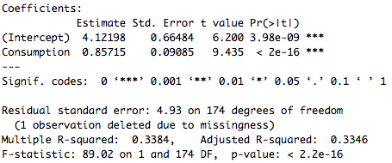
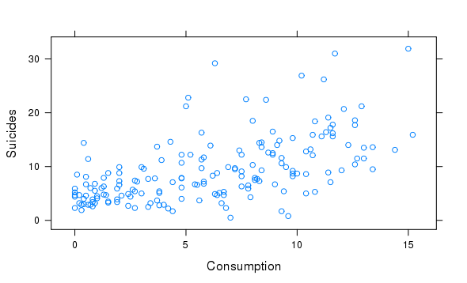
Figure 1. Table 1.
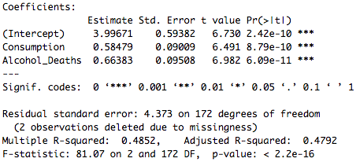
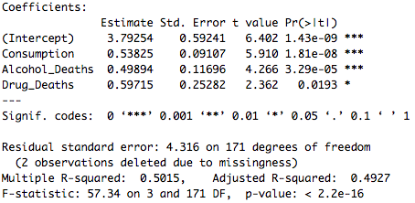
Table 2. Table 3.

The mean suicide rate of a country was 9.29 suicides per 100,000 individuals (standard deviation of 6.04), and the mean alcohol consumption rate was 6.07 liters of pure alcohol per capita (standard deviation of 4.10). Figure 1 shows a clear correlation between the amount of alcohol consumed by a country and its suicide rate. At a significance level of α = 0.05, we found a significant linear relationship between alcohol consumption and the suicide rate of a country before (Table 1) and after controlling for alcohol- and drug-related deaths (Tables 2-3). The regression coefficient of consumption in our final three-predictor model implies that, for every 2-liter increase in per capita alcohol consumption per year, the suicide rate of that country will increase by an average of one suicide per 100,000, assuming the values of alcohol- and drug-related deaths remain the same. Similarly, the two variables measuring substance abuse-related deaths imply that, for every additional two deaths per 100,000 that occur due to substance abuse disorders, the suicide rate of a country will increase an average of about one suicide per 100,000, assuming the values of the other variables stay constant.
Alcohol consumption alone explained nearly 1/3 of the variability in the suicide rate of a country (Table 1, adjusted R² of 0.3384). When numbers of alcohol- and/or drug-related deaths were also included, the adjusted R² value rose to nearly 1/2 (Tables 2 and 3). While these predictors are correlated (see the Appendix, Figures 2-4), the degree of the collinearity observed was not sufficient to doubt the validity of the model. For example, the correlation between the amount of alcohol consumed and the number of drug-related deaths was 0.44. A similar correlation was observed between the amount of alcohol consumed and the number of alcohol-related deaths. However, the correlation between alcohol- and drug-related deaths was much higher at 0.68, making it difficult to separate their independent effects.
To examine the assumptions of our model, we first plotted the residuals of our final three-predictor model against the fitted values (Appendix, Figure 5). There were some noticeable outliers, for example, some with fitted values of about 10 suicides per 100,000, but after excluding those, there does not appear to be a strong deviation from the constant variance assumption. Similarly, because there is no evidence of any pattern in the residuals when plotted against the fitted values, we concluded that the predictors have strong linear relationships with the response variable. Finally, we plotted a histogram of the residuals (Appendix, Figure 6) and a normal probability plot of the sample quantiles against theoretical quantities (Appendix, Figure 7). Although the sample quantiles are slightly more extreme than expected when compared to the normal distribution, the residuals appear be roughly normally distributed, suggesting that the assumption of normal errors is reasonable.

Conclusions/Inferences
We found that alcohol consumption, deaths attributed directly to alcohol use disorders, and deaths attributed directly to drug use disorders all had strong linear relationships with the suicide rate on a country-wide level. While these findings are statistically significant, we were unable to measure the intangible factors that determine a society’s tendencies to consume more alcohol or to be more prone to alcohol- or drug-use disorders. However, our study extends the link between alcohol consumption and suicidality from individuals to countries. As a result, our regression model may have important implications for the role of alcohol consumption in a nation. For example, consider a country such as Russia, which has an alcohol consumption rate of about 12 liters of pure alcohol per capita per year. According to our final model, a 2-liter increase in per capita alcohol consumption is linearly associated with an average increase of one suicide per 100,000, holding all other variables constant. Consequently, an alcohol consumption rate of 12 liters of pure alcohol per capita is predicted to increase the suicide rate of a country by about six suicides per 100,000 when compared to a country with an alcohol consumption rate of zero liters per capita. Even alcohol consumption alone may account for over 8,000 suicides, which is approximately 20% of the suicides in Russia in 2016.
Our model validates the existing literature on the comorbidity of substance abuse disorders and suicidality [1] by evaluating different components of substance abuse on an international scale. By illustrating the consequences of substance abuse disorders, we hope to influence policy makers to actively implement programs for those in need. Although addressing mental health directly is often very challenging, the significant relationship between substance use and suicidality leads us to believe that there are pragmatic policy decisions a country can make to reduce the loss of life.

References

1. Pompili M, Serafini G, Innamorati M, et al. Suicidal behavior and alcohol abuse. Int J Environ Res Public Health. 2010;7(4):1392-431. Retrieved from https://www.ncbi.nlm.nih.gov/pmc/articles/PMC2872355/

2. Stone DM, Simon TR, Fowler KA, et al. (2015) Vital Signs Trends in State Suicide Rates — United States, 1999–2016 and Circumstances Contributing to Suicide — 27 States, 2015. MMWR Morb Mortal Wkly Rep 2018, 67:617–624. Retrieved From https://www.cdc.gov/mmwr/volumes/67/wr/mm6722a1.htm?s_cid=mm6722a1_w

3. Ritchie, H. & Roser, M. (2018) Substance Use. Our World in Data. Retrieved From https://ourworldindata.org/substance-use

4. World Health Organization (2018) Suicide Rate Estimates, Crude Estimates by Country. Global Health Observatory Data Repository. Retrieved From http://apps.who.int/gho/data/view.main.MHSUICIDEv?lang=en

5. World Bank (2018) Total alcohol consumption per capita (liters of pure alcohol, projected estimates, 15+ years of age.) World Health Organization, Global Health Observatory Data Repository. Retrieved From https://data.worldbank.org/indicator/SH.ALC.PCAP.LI?end=2016&start=2016&view=chart

6. World Bank (2018) ( 1 ) United Nations Population Division. World Population Prospects: 2017 Revision. ( 2 ) Census reports and other statistical publications from national statistical offices, ( 3 ) Eurostat: Demographic Statistics, ( 4 ) United Nations Statistical Division. Population and Vital Statistics Report ( various years ), ( 5 ) U.S. Census Bureau: International Database, and ( 6 ) Secretariat of the Pacific Community: Statistics and Demography Programme. World Health Organization, Global Health Observatory Data Repository. Retrieved From https://data.worldbank.org/indicator/SP.POP.TOTL

Appendix

Figure 2. Figure 3.
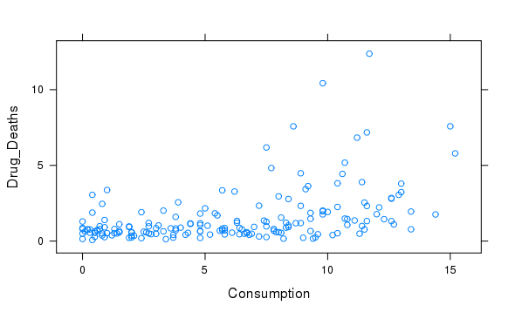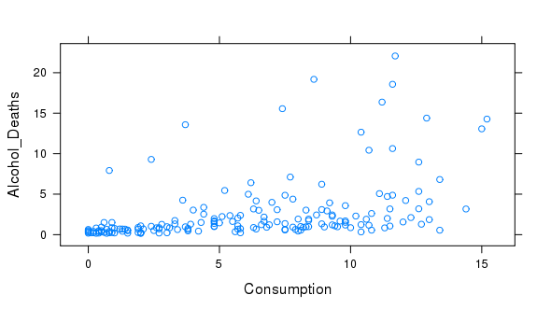

Figure 4. Figure 5.
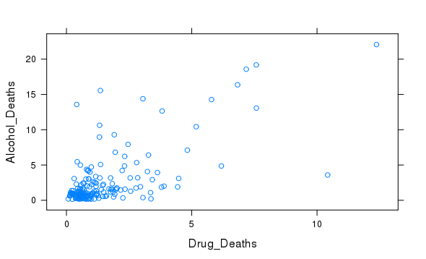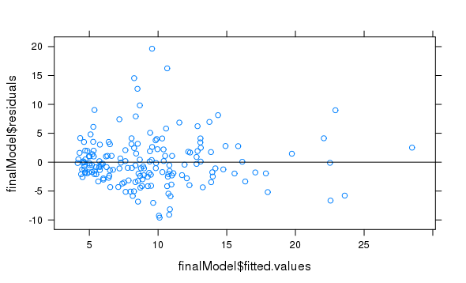
Figure 6. Figure 7.
