**Understanding the 2016 Presidential Election: An analysis of how economic and race/immigration politics influenced swing voters**

**Abstract**

The 2016 US Presidential Election was unprecedented, as traditional prediction methods failed to forecast the outcome. Using a demographic and political opinion survey of confirmed voters, we characterized President Trump’s voters, particularly “non-Republicans,” with two hypotheses: 1) Trump voters were economically downtrodden and 2) voters aligned with Trump’s immigration and race rhetoric. We created two multilevel models with voter and state level variables and found partial support for the “economically downtrodden” hypothesis: a belief the economy became worse under President Obama was a strong predictor of a non-Republican vote for Trump. Actualincome was not a significant predictor of vote. We also found support for the “race politics” hypothesis: supporting policies to curb immigration was a meaningful predictor non-Republicans would vote for Trump. While Republicans largely followed party lines, swing voters expressed discontent with the status of current economic and immigration/race issues and propelled Trump to the White House.

**Introduction**

In the 2016 presidential election, polls and predictive models failed to predict Donald Trump’s victory. Since the election, many hypotheses have circulated as to why Trump received many unexpected votes. We set out to study the driving forces behind Trump’s win by evaluating common characteristics among his voters. We evaluated two working hypotheses among political scientists using multi-level statistical modeling. The first hypothesis studied is that Trump voters tended to be economically downtrodden, voting for Trump as a candidate of change because of personal economic hardships. While this hypothesis finds support in popular media, there is evidence in opposition to it.1 The second hypothesis is that Trump exploited fear of minorities and immigrants, therefore Trump voters’ thoughts tend to parallel this rhetoric. Previous studies identified fear of losing majority status indeed impacts voting choice.2 In addition, we assess how Trump’s social rhetoric affected religiously-motivated voting, since his campaign emphasized retaliating against increasing secularization of the political landscape. Political scientists disagree on the causes of Trump’s unexpected victory, but the hypotheses we evaluate relate to some of the most popular working theories attempting to explain the 2016 presidential election outcome.

**Methods**

The data came from the 2016 Cooperative Congressional Election Survey (CCES),3 which was conducted in the fall of 2016 over the internet by YouGov (an online polling site). The survey attempted to yield responses that would explain how Americans view the government and their representatives, and how voter behavior and sentiment vary geographically and socially. Supplemental state-level information, including minority and foreign born population proportions, and population density, was included from census sources.

Voting behavior is complex, driven by an individual’s social and economic characteristics, as well as characteristics of a person’s environment in which they live. Thus, to consider and account for a voter’s surrounding environment, this analysis utilized multi-level modeling. At level one were predictors pertaining to the individual voter and at level 2 were predictors at the state level. Our response variable for all analyses is vote for Trump or another candidate. Our final dataset consisted of 44,644 observations after omitting observations with missing data for key variables.

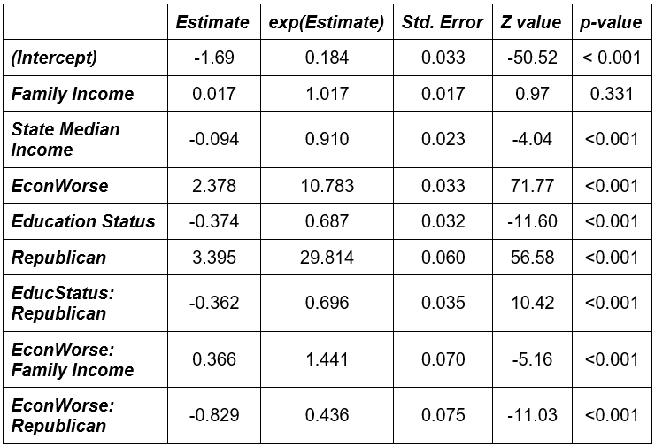Using the cleaned dataset, we built separate models for each hypothesis, creating a “economic model” and a “race politics” model. All modeling was done with the glmer package in R. Models were constructed by progressively adding variables of interest and assessing how they impact the model. The interactions of added variables with variables already in the model at both levels were also assessed. The criteria for keeping added variables or interactions was a likelihood ratio test concluding a statistically significant difference (p<0.05) between the more complex and null models. For all models, only a single random effect (random intercepts type model) was considered at level 2.

**Results**

*Hypothesis 1 (Economic Model)*



From this final model (Table 1), we find that family income was not a significant predictor of a Trump vote; however the interaction between family income and view of the economy was statistically significant. In this case, adjusting for state median income, education status, and political party, a voter who believed the economy was worse had 6.5% higher odds of voting for 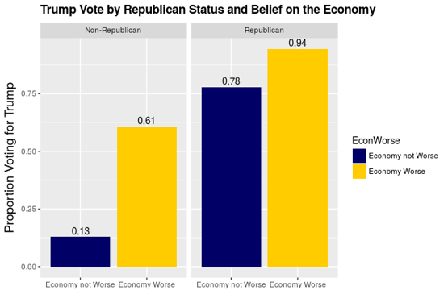Trump for each additional $10,000 in family income (opposed to 0.2% increased odds for each $10,000 of income for voters who did not believe the economy was worse). The effect in believing the economy has gotten worse was greater for non-Republicans than for Republicans (Figure 1). For non-Republicans with the mean family income (Z-score of zero), the odds of voting for Trump are 10.78 times higher for voters who believed the economy has gotten worse, than for voters who did not believe the economy has gotten worse, after controlling for state income and education status. This same effect for Republicans was only a 4.7 times increase in odds of voting for Trump. This discrepancy decreases as family income increases. No other predictors assessed significantly contributed to the model, nor were any interactions between person state level variables statistically significant.

**Table 1**. Final Model for the Economic Hypothesis. Exponentiated values of coefficients are used for interpretations.



**Figure 1.** Trump Vote by Republican Status and Belief on the Economy.

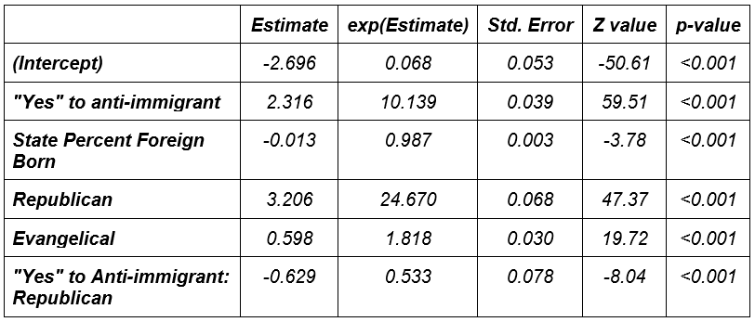*Modeling Results: Hypothesis 2 (Race Politics Model)*

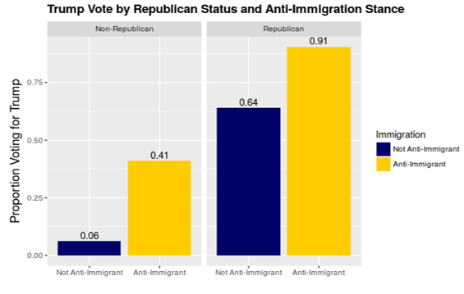The final model for the race politics model is seen in Table 2. We find, adjusting for support of anti-immigrant policy, Republican status, and evangelical status, that for each ten percent increase in percent foreign born residents in a state, the odds of voting for Trump decrease by 12% on average. Likewise, adjusting for all other variables, evangelical Christians have 1.82 times greater odds of voting for Trump compared to non-evangelicals. While supporting anti-immigrant policies is associated with increased odds of voting for Trump, a fascinating interaction is observed with Republican party identification (Figure 2). Non-Republicans who expressed approval for anti-immigration policies had 10.2 times greater odds of voting for Trump than those opposed to anti-immigration policies, when adjusting for state percent foreign born and evangelical status. A smaller effect of anti-immigrant policy approval is observed for Republicans who had 5.40 times greater odds of voting for Trump than those opposed to anti-immigrant policies after adjusting for the same variables.

**Figure 2**. Trump Vote by Republican Status and Anti-Immigration Stance.

**Table 2**. Final Race Politics Model. Exponentiated values of coefficients are used for interpretations.

**Discussion**

We found partial support for the economic hypothesis. We did not see evidence that actual economic status influenced voting for Trump: family income alone was not a predictor of Trump vote. However, we found voters’ outlook on the economy to be a significant predictor of Trump vote, with voters believing the economy has gotten worse having much higher odds of voting for Trump than those that do not view the economy negatively. Moreover, we found a significant interaction between Republican party identification and economic outlook. The effect of believing the economy has gotten worse was significantly greater for non-Republicans than for Republicans. Only 13% of non-Republicans who did not believe the economy was getting worse voted for Trump, while 61% of non-Republicans who *did* believe the economy was getting worse voted for Trump. This is a strong characterization of “swing voters”: Republicans voted for Trump at a high rate regardless of their personal economic views, but voters gained from outside the party largely agreed with Trump’s position that the economy was stifled under President Obama. Additionally, as voters become more affluent, they were more likely to translate a belief the economy was getting worse into a vote for Trump.

In the minority politics hypothesis, we found that even after adjusting for Republican status, support of anti-immigration policy, evangelical status, and state foreign born population are significant predictors of a Trump vote. We also found that the effect of supporting anti-immigrant policies was less for Republicans than for non-Republicans. This may seem counter-intuitive, since the anti-immigrant policies mentioned in the survey were unique to Trump’s political platform. However, anti-immigrant sentiments were a greater predictor of a Trump vote for people who don’t usually call themselves Republicans. This can be characterized as a swing vote. The ability of rhetoric espousing fear of minorities to shift votes is consistent with the study by Major et al. that motivated our investigation of this hypothesis.

Two additional findings were notable from the second model. First, we found a decrease in Trump votership as the proportion of foreign born residents in a state increased. It may be that people who lived in the presence of many immigrants were less likely to support anti-immigrant policies, or simply that locales with more foreign born residents had more minority voters, who were known to support Trump less than white voters. Additionally, an increase in odds of voting for Trump among evangelicals was consistent with Trump’s rhetoric of seeking to “restore” Judeo-Christian values to the government, protecting against a growing population of non-Christians.

Considering the large size of our sample and the range of responses across all fifty states, our results can be reasonably generalized to voters for the presidential election in 2016. There are several limitations to this study. In the initial exploratory data analysis, we find 40.6% of respondents voted for Trump, meaning voters are slightly under-represented in the sample: Trump actually won 46.1% of the popular vote. Additionally, considering the amount of social, economic, and political variation within states, a more specific level 2 observational unit would have been ideal.

In the divisive 2016 presidential election, much was unprecedented, including campaign rhetoric, media coverage, and a failure of polls and models to predict the true outcome. We find a substantial influence from “swing” voters and voters who previously did not identify with a political party. These voters can be largely characterized by their support of anti-immigrant policies and/or negative outlook on the economy. As major points of Trump’s rhetoric, it seems his message was received and motivated people to vote for him.

**References**

1. Manza, J., & Crowley, N. (2017). Working Class Hero? Interrogating the Social Bases of the Rise of Donald Trump. *The Forum,* *15*(1). doi:10.1515/for-2017-0002
2. Major, B., Blodorn, A., & Blascovich, G. M. The threat of increasing diversity: Why many White Americans support Trump in the 2016 presidential election. Group Processes & Intergroup Relations, 0(0), 1368430216677304. doi:10.1177/1368430216677304
3. Ansolabehere, S., & Schaffner, B. F. (2018). CCES Common Content, 2016 (doi/10.7910/DVN/GDF6Z0). from Harvard Dataverse <https://doi.org/10.7910/DVN/GDF6Z0>