Prolonged steeping time decreases the pH of Tea

ABSTRACT

The goal of our experiment was to test whether steeping time or tea brand had a significant effect on the pH of green tea. We used a two-way factorial design to collect data, and analyzed the main effects using an ANOVA. We found no interaction between the factors of tea brand and steeping time. Both steeping time and tea brand were found to independently affect the pH of the tea. As steeping time increased, the pH of the tea decreased. Lipton green tea had a lower pH on average compared to Bigelow green tea.

BACKGROUND AND SIGNIFICANCE

Tooth erosion does not occur until the tooth is exposed to a solution in the pH range 2.0-4.0, however, the surface enamel can demineralize when exposed to a solution that drops below pH 5.5.¹ Even limited exposure of teeth to acidic beverages such as consumption of the beverage leads to erosion of both tooth enamel and root surfaces.² Because the pH of some teas have been recorded as having a pH below 5.5, this class of commonly consumed beverages has the potential to degrade the teeth of those who consume tea.³ Additionally, steeping time has been shown to affect the chemical properties of tea, so we sought to discover whether the steeping time of the tea had an impact on the resulting pH of the beverage.⁴ Rather than suggest that consuming tea will prove harmful for the longevity of tooth enamel and root surfaces of those who consume it, we intended to find and optimal steeping time that allows consumers the freedom to drink tea without the negative repercussions on their dental health.
Our research questions were: How does the steeping time of tea affect the acidity of the tea? Does the brand affect the acidity of the tea? Is there an interaction between brand and steeping time?
Our hypotheses were: 1) The tea would be more acidic with a greater steeping time.⁵
2) The pH for Bigelow tea would be different from the pH for Lipton tea on average.

MATERIALS AND METHODS

Experimental Design
This study was conducted as a two-way factorial design with a single blocking factor. The two factors were tea brand (Lipton and Bigelow) and steeping time (1 minue, 3 minutes, 5 minutes and 15 minutes) and the experiment was blocked by set. There were five sets, each of which contained the eight possible combinations of tea brand and steeping time. With five sets of eight observations, we had forty total observations (five for each treatment).
Procedure
Each period of data collection was marked by a set which included one iteration of each of the 8 treatments. Each beaker was randomly assigned a treatment based on the five sets of eight random numbers that we generated using SAS. For each cup of tea, we poured 300mL of heated Grinnell tap water into a 600mL glass beaker. We let the water cool to 80°C before adding the tea prescribed by the random treatment assignment. Immediately upon entry of the tea bag in the water, the timer started and the tea bag was removed after steeping in the hot water for the assigned amount of time. Directly following the removal of the tea bag, the pH was measured using a pre-calibrated pH probe. 5 total sets were recorded with each set containing 8 total measurements: one from each tea brand at all four time lengths. As the tea steeped, the beaker was left in ambient conditions, allowing the tea to cool as it would under standard tea drinking conditions. For each measurement, the tea water began at 80 °C, but the temperature at which the pH was measured is unknown. A measurement of the pH of the plain tap water heated to 80 °C was collected to compare the pH of the plain water to the pH of the steeped tea.

RESULTS

Tables 1 & 2 show the mean values for each level of both factors. We performed a two-way ANOVA to measure the main effects of tea brand & steeping time, and test for an interaction between these two factors (results in table 4 of the appendix). There was no significant evidence to indicate an interaction between steeping time and tea brand, as the p-value was 0.8615, and greater than our alpha level of 0.05. The lack of interaction is further demonstrated by the interaction plot shown in figure 1, as all 4 lines appear to be relatively parallel, and the effect of one factor remains relatively the same at all levels of the other factor.
Table 2: Mean pH estimates for all levels of tea brand. N = 20 for each group. The standard error for each estimate was 0.03210.
Table 1: Mean pH estimates for all levels of steeping time. N = 10 for each group. The standard error for each estimate was 0.04539.

Steeping Time (minutes) | pH Estimate
1 | 7.6710
3 | 7.3500
15 | 7.0730
30 | 7.0120
Brand | pH Estimate
Bigelow | 7.4815
Lipton | 7.0715

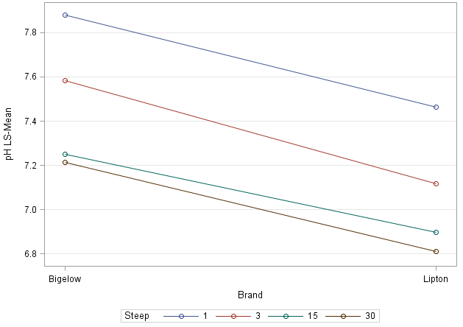
Figure 1: Interaction between factors of steeping time and tea brand of pH of tea. N = 5 for each treatment group.

Looking at the main effects, there was significant evidence to indicate that steeping time affected the pH of the tea, as the p-value was less than 0.0001. Looking at the means in table 1, there appears to be a trend of decreasing pH as the steeping time increases. Additionally, there was significant evidence to indicate an effect of tea brand on the pH of the tea, as the p-value was found to be less than 0.0001. Looking specifically at the means in table 2, Bigelow was found to have a higher and less acidic pH, compared to Lipton green tea. There was found to be no significant difference between the sets of our blocking factor, and the mean pH value for each set were all around 7.3. Also of note, the pH of the tea only fell below 7 (to become acidic) for two treatments (7&8), which both used Lipton tea and had steeping times of 15 and 30 minutes.
For additional analysis, we performed multiple comparisons on the different levels of the steeping time factor, and used a Tukey adjustment. Nearly all of the steeping times were found to be significantly different from each other at an alpha level of 0.05, and the p-values were all much lower than 0.05 (full results are in table 5 of the appendix). The only steeping times that were not found to yield a significantly different pH from each other were 15 and 30 minutes. Lastly, we also performed a contrast to test the null hypothesis: μ₁+ μ₃ = μ₁₅+ μ₃₀, which tested whether the average pH of the short steeping times was equal to the average of the long steeping times. There was evidence to support alternative hypothesis that average pH of the short steeping times was significantly different from the average of the long steeping times, as the p-value was found to be less than 0.0001, and much less than the alpha level of 0.05.

DISCUSSION

We found a significant effect of steeping time and tea brand on the pH of green tea. We did not find a significant interaction between the factors of tea brand and steeping time.
Specifically, an increase in steeping time correlated with a decreasing (and more acidic) pH, which agreed with our initial hypothesis and additional sources.⁵ For the factor of tea brand, Lipton green tea was found to have on average a lower (and more acidic) pH compared to Bigelow green tea.
An interesting observation for this experiment was that the water used (tap water in Grinnell) was more basic than initially expected. Water usually has a neutral pH of 7.0; however, the Grinnell tap water had a pH of 8.06 at room temperature (22°C), and a pH of 9.01 at 80°C. As water boils, the acidic gases dissolved in the water are released in the atmosphere, causing the water to become more basic.⁶ Thus, since our water was not at a starting pH of 7, as we had initially predicted, but rather started around a pH of 9, the tea steeping did not yield a pH below 7 for most of the treatments, but still became more acidic, as evidenced by a drop in pH.
There are a few adaptations that could be made to this experiment in order to clarify and expand the findings. One way, would be to measure the initial pH of the water before the tea bag is inserted, and then subtract this from the final pH, so as to record a change in pH, rather than a final pH that could have been influenced by water type or source. Alternatively, as a control, we could just use water without tea, and measure the pH at each time factor, as the water cools. This would account for water source variation and change in pH with temperature.
Overall, we can likely suggest that our data does not provide evidence that either Bigelow or Lipton green tea steeped for any length of time less than 30 minutes in Grinnell’s tap water would yield an acidic beverage that could harm to tooth enamel.

References:
- Reddy, A., Norris, D. F., Momeni, S. S., Waldo, B., & Ruby, J. D. (2016). The pH of beverages available to the American consumer. Journal of the American Dental Association (1939), 147(4), 255–263. http://doi.org/10.1016/j.adaj.2015.10.019
- Ehlen, L. A., Marshall, T. A., Qian, F., Wefel, J. S., & Warren, J. J. (2008). Acidic beverages increase the risk of in vitro tooth erosion. Nutrition Research (New York, N.Y.), 28(5), 299–303. http://doi.org/10.1016/j.nutres.2008.03.001
- Simpson, A., Shaw, L., Smith, A.J. (2001). Tooth Erosion: Tooth surface pH during drinking of black tea. British Dental Journal, 190, 374-376.
- Hajiaghaalipour, F., Sanusi, J. and Kanthimathi, M. S. (2016), Temperature and Time of Steeping Affect the Antioxidant Properties of White, Green, and Black Tea Infusions. Journal of Food Science, 81: H246–H254. doi:10.1111/1750-3841.13149
- Acidity of Tea. (2015, April 03). Retrieved May 08, 2017, from https://ratetea.com/topic/acidity-of-tea/79/
- Dye, J.F. (1952). Calculation of effect of temperature on pH, free carbon dioxide, and the three forms of alkalinity. J. Am. Water Works Assoc., 44(4): 356–372.

APPENDIX

Table 4: Results from ANOVA performed to test the effects of steeping time and tea brand, along with an interaction, on the pH of the tea.
Effect | Num DF | Den DF | F-Value | P-value
Steeping Time | 3 | 28 | 44.07 | <.0001
Brand | 1 | 28 | 81.59 | <.0001
Steeping Time*Brand | 3 | 28 | 0.25 | 0.8615
Set | 4 | 0 | 0.45

Table 5: Results from a multiple comparison analysis of the different levels of steeping time with a Tukey adjustment.
Steeping Time (A) | Steeping Time (B) | DF | T-value | Adjusted P-value
1 | 3 | 28 | 5.00 | 0.0002
1 | 15 | 28 | 9.32 | <0.0001
1 | 30 | 28 | 10.27 | <0.0001
3 | 15 | 28 | 4.32 | 0.0010
3 | 30 | 28 | 5.27 | <0.0001
15 | 30 | 28 | 0.95 | 0.7782

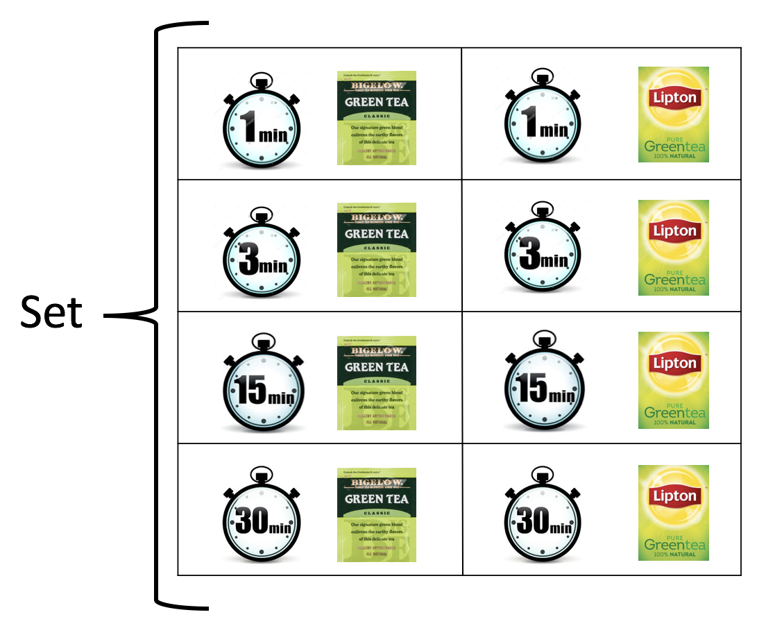
Figure 2: A picture depicting the design of our experiment.

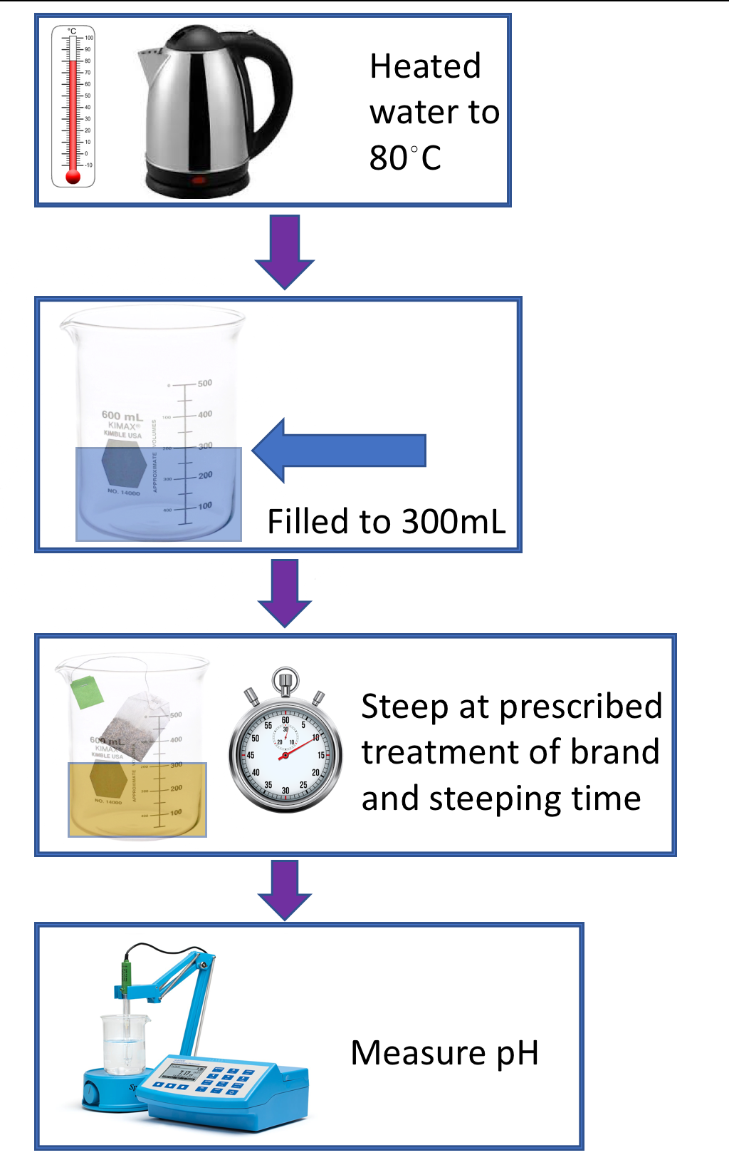
Figure 3: A picture flow-chart to further illustrate the methods of our study.

Treatments:
1. 1 minute + Bigelow
2. 3 minutes + Bigelow
3. 15 minutes + Bigelow
4. 30 minutes + Bigelow
5. 1 minute + Lipton
6. 3 minutes + Lipton
7. 15 minutes + Lipton
8. 30 minutes + Lipton

Random Number Assignments:
Set 1: 6, 3, 1, 2, 4, 5, 8, 7
Set 2: 3, 2, 1, 8, 7, 4, 5, 6
Set 3: 2, 3, 4, 7, 1, 6, 5, 8
Set 4: 1, 8, 3, 2, 6, 7, 5, 4
Set 5: 1, 5, 3, 6, 7, 8, 4, 2

Table 6: Average pH values for each treatment.
Treatment number | Brand | Steeping time (minutes) | Average pH
1 | Bigelow | 1 | 7.88
2 | Bigelow | 3 | 7.582
3 | Bigelow | 15 | 7.25
4 | Bigelow | 30 | 7.214
5 | Lipton | 1 | 7.462
6 | Lipton | 3 | 7.118
7 | Lipton | 15 | 6.896
8 | Lipton | 30 | 6.81

