Can You Tell the Difference?
A Study on the Preference of Bottled Water

Abstract
Our study aims to discover if people will rate the taste of bottled water differently than tap water across three different conditions. We first did this in a blind test and did not find a significant difference. We then wanted to see if the subjects knew (or thought they knew) which water was which would make a difference. So in our second test we disclosed the type of water to the participants (truth condition) and in our third test we falsely disclosed the type of water to participants (lie condition---they thought the tap was bottled and the bottled was tap). In these last two tests participants significantly rated the taste of bottled water higher in the truth condition and the taste of tap water higher (which they thought was bottled water) in the lie condition.

Background and Significance
Bottled water as we know it was first introduced in the United States in 1809 by Joseph Hawkins, and was made popular for its decreased production costs compared to traditional practices. More importantly, bottled water became such a staple in our country because it was advertised as the only sure way to drink water free of the risk of acquiring cholera and typhoid in a time where water given to the general population was not nearly as purified as it is today. Those who could afford to use only the bottled water (to drink, clean, and bathe) were less likely to acquire these diseases that were spreading across the country and killing many. (Hall, 2009) Surely, bottled water served an important purpose in that time; however, do we still need it today since tap water is very safe? Perhaps people are still buying bottled water for the taste.
There has been some research already done in this field, like the Boston University Vermont Pure Natural Spring Water Test. Students at Boston University tested to see if other students could pick which water sample was tap and which was bottled in a blind test. They found that of 67 testers, only one third were able to correctly identify the water sample. Additionally, a French research team ran a taste test of six different bottled mineral waters and six municipal tap waters with 389 participants. The report concludes that "most consumers cannot distinguish between bottled water and tap water when the latter is chlorine-free.” (Teillet et al, 2010) Researchers concluded that "The findings from this study indicate that people cannot correctly identify bottled water on the basis of its flavor, this suggests that the currently high consumer demand for this beverage must be based on factors other than taste or olfactory perception." (Friday, 2011) Our study aimed to discover what this other factor could be.

Methods
In order to collect data for our study, we approached 93 students in their residences. We randomly decided which doors to knock on, although many of the participants were our friends or acquaintances. We told the first 31 participants to taste two different types of water that had been previously poured into small cups. We used tap water (from the sink) and Nestle Pure Life for our bottled source. The participants were not told anything about the water; their only instructions were to taste both cups of water (labeled A and B) and rate each on a scale of 1 (terrible) to 7(great). This was our “blind” condition.
The next group of 31 participants was aware of which type of water they were drinking. We poured them two samples of water in front of them and then they were asked to taste the contents of each cup and rate the taste of both on a scale of 1-7. This was our “truth” condition.
The third and final group of 31 participants was deceived regarding which type of water they were tasting and rating. We achieved this by emptying bottled water into a pitcher and filling the empty bottles with water from the tap beforehand. After this we poured the “fake” tap water and the “fake” bottled water into cups in front of the participant. They were instructed to taste each sample of water and rate the taste of each on a scale of 1-7.

Results of Test 1: Difference in taste between tap and bottled water- Control Condition
We first tested to see how people would rate our two sample waters blind. The mean rating for the tap water was 4.03 (SD= 1.74) and for bottled water was 4.06 (SD= 1.50). The observed difference in means (tap − bottled) was -0.032 (SD= 1.975), meaning the subjects rated the tap water sample, on average, 0.032 points lower than the bottled water sample. The results are shown in Figure 1 below.
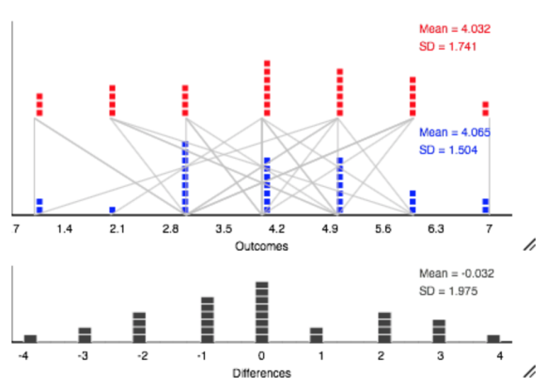 | Figure 1: The results of the blind test with tap water scores (on top in red) compared to bottled water scores (on bottom in blue). Each pair of connected dots represents the recorded taste score of each participant, and the lines connecting the dots show the change in each participant's rating between tap and bottled water. The bottom graph is a graph of these differences

Doing a simulation-based matched pairs test with the 31 participants comparing the change of the two means with 5,000 simulations, we found a (two-sided) p-value of 1.000 so we have no evidence that there is a difference in mean ratings.

Result of Test 2: Difference in taste between tap and bottled water- Truth Condition
We then tested to see what would happen if we disclosed the type of water to the participants that they were sampling. Participants were shown what sample contained tap water and which contained bottled water. The mean rating of tap water was 4.323 (SD=1.469) and for bottled water was 5.065 (SD=1.181). This lead to a mean difference (tap − bottled) of -0.742 (SD=2.081) meaning that, on average, the subjects rated the taste of tap water 0.742 points lower than bottled water. The results are displayed in Figure 2 below.
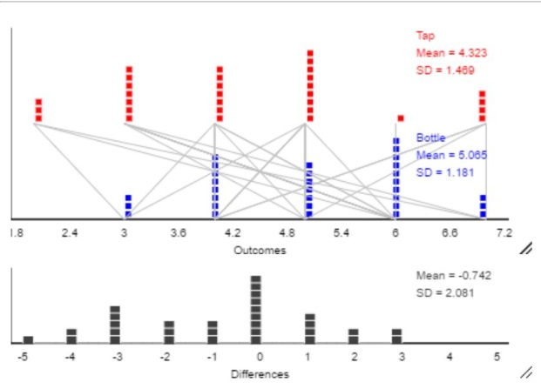 | Figure 2: The results of tap water ratings (on top in red) compared to bottled water ratings (on bottom in black). Each pair of dots (connected by a line) represents one participants’ recorded rating for both samples in the study. The means of the data show clearly that bottled water is rated higher on average than tap water. The bottom graph is a graph of these differences

After a 5,000 trial simulation test comparing the 31 matched pairs, we found a (two-sided) p-value of 0.0454 so we have strong evidence that there is a difference in mean ratings with bottled water rated higher, on average.

Results of Test 3: Difference in taste between tap and bottled water- Lie Condition
We then tested to see what would happen if we reversed the samples of water, thereby lying to the participants. Although we will still report true bottled water as bottled and true tap water as tap, it is important to note that the participants believed the bottled water they were tasting was tap, and that the tap water they were drinking was bottled. The mean rating of tap water was 4.806 (SD=1.797) and for bottled water was 3.903 (SD=1.446). This lead to a mean difference (tap − bottled) of 0.903 (SD=2.103), meaning that on average, people rated the taste of tap water 0.903 points higher than bottled water. The results are displayed in Figure 3 below.
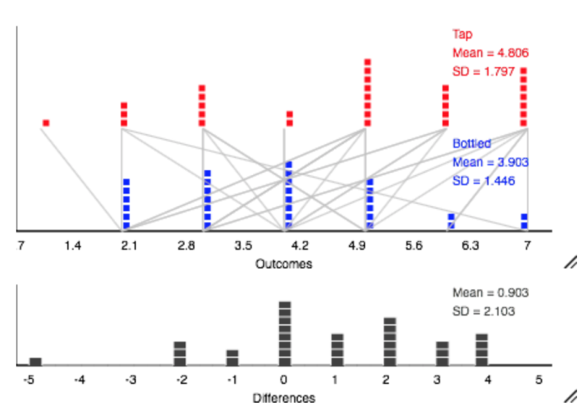 | Figure 3: The results of tap water ratings (on top in red) compared to bottled water ratings (on bottom in black). Each pair of dots (connected by a line) represents one participant’s recorded rating for both samples in the study. The means of the data show clearly that tap water is rated higher on average than bottled water. The bottom graph is a graph of these differences
After a 5,000 trial simulation test comparing the difference in means of the 31 matched pairs, we found a (two-sided) p-value of 0.0282 giving us strong evidence of a difference. We have strong evidence that people will rate the taste of tap water higher than bottled water when they believe they are in fact drinking bottled water, not tap.

Discussion/Conclusion
Our results indicated that people on average, cannot tell the difference between tap water and bottled water as shown in our first test. This seems to support previous findings (Friday, 2011). Since in a blind test, people could not discern tap from bottled water, we decided to take our experiment to the next level and tell people which water was which to see what effect it would have on taste ratings. We found that that people rate the taste of bottled water significantly higher than tap when they know what they are drinking.
We decided then to see the effect switching the labels would have on how people would rate the taste of the water samples. In our third test we were able to demonstrate that people will rate the taste of tap water (when they think it is bottled) higher than bottled water (when they think it is tap). The only explanation for this is a label or packaging. Our data supports the notion that people care about the packaging of their product; they care about what they think they're drinking. This conclusion is supported by other previous research findings (Teillet et al, 2010.) In other words, how people think their water tastes depends on the way that it is delivered to their mouths, and not the water itself. The taste “preference” for bottled water seems to be merely psychological, as the data supports.
The implications of these results are vast when considering the harmful effects of the bottled water industry. It would be our hope that our study would encourage people away from the purchasing of bottled water and towards the use of tap water, as long as there is no statistical difference in taste between the two options.
In our study we could have done a few things differently. We could have used more than one type of bottled water and more than one type of tap water, as people from certain geographical regions may have a greater preference for one type of water over another. We could have also selected a more diverse sample. Although we found significant results that were supported by previous literature, further research needs to be done. Perhaps a new study would obtain different results when testing taste ratings across different brands of bottled water and different populations. Will children reflect the same psychological preference for bottled water? The elderly? These questions would need to be addressed in future investigations.

References:
- Hall, N. (2009, March). A Brief History of Bottled Water in America. http://www.greatlakeslaw.org/blog/2009/03/a-brief-history-of-bottled-water-in-america.html, Retrieved April 25, 2017.
- Friday, L. (2011, March 24). Bottled vs. Tap: Which Tastes Better? | BU Today | Boston University. Retrieved April 18, 2017
- Teillet, E., Urbano, C., Cordelle, S., & Schlich, P. (2010, April 19). Consumer Perception and Preference of Bottled and Tap Water. Journal of Sensory Studies, 25: 463–480. doi:10.1111/j.1745-459X.2010.00280.x, Retrieved April 18, 2017
- The Water Project. Bottle Water is Wasteful. (June, 2015). https://thewaterproject.org/bottled-water/bottled_water_wasteful Retrieved April 18, 2017

Appendix:

Test 1: Control Condition

For our first test we had the following hypotheses:

Null: There is no difference in the mean ratings between tap and bottled water (μ_{d} = 0)
Alternative: There is a difference in the mean ratings between tap and bottled water (μ_{d} ≠ 0)

We used the applets that go along with the Introduction to Statistical Investigations text to do our analysis, http://www.rossmanchance.com/ISIapplets.html. We used the matched pairs applet to test the relationships of subjective taste scores between the two water samples of each participant. We found our observed difference to be -0.032 (tap − bottled). Through simulated-based testing, we developed a null distribution of 5,000 trials and found our p-value to be 1.0000. We determined that this incredibly large p-value did not provide strong evidence against the null hypothesis. We found a 95% confidence interval for the difference in means of (-0.7564, 0.6924).
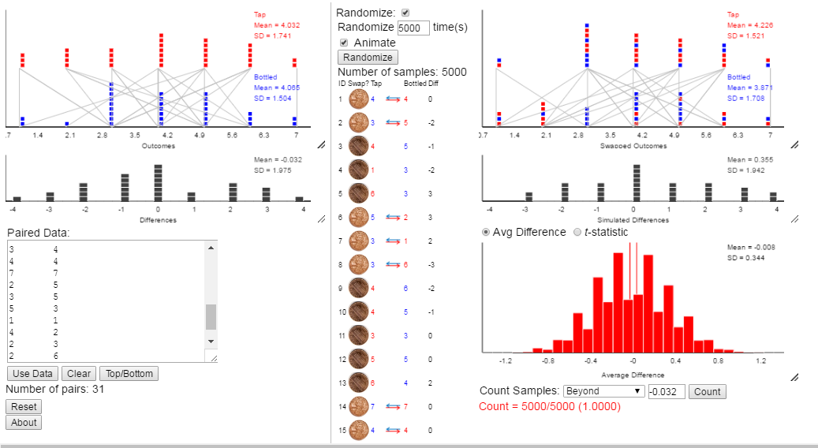

Test 2: Truth Condition
For our second test we had the following hypotheses:

Null: There is no difference in the mean ratings between tap and bottled water (μ_{d} = 0)
Alternative: There is a difference in the mean ratings between tap and bottled water (μ_{d} ≠ 0)

We used the matched pairs applet again to test the difference in taste scores when we disclosed the type of water in each sample. Our observed difference is -0.742 (tap − bottled).. After a null distribution was created using 5,000 trials, we found our p-value to be 0.0454. We determined that this small p-value provided strong evidence against the null hypothesis.

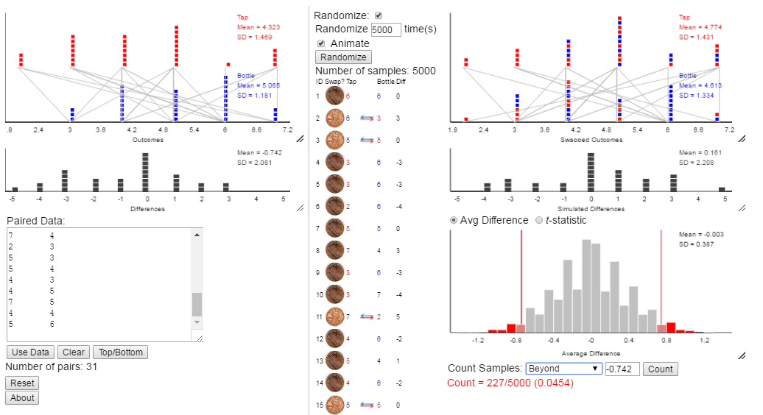

Test 3: Lie Condition

For our third test we had the following hypotheses:

Null: There is no difference in the mean ratings between tap and bottled water (μ_{d} = 0)
Alternative: There is no difference in the mean ratings between tap and bottled water (μ_{d} ≠ 0)

We used the matched pairs applet again to test the difference in taste scores when we lied to participants about the types of water samples (tap = bottled & bottled = tap). Our observed difference is 0.903 (tap − bottled). After a null distribution was created using 5,000 trials, we found our p-value to be 0.0282. We determined that this small p-value provided strong evidence against the null hypothesis.

