A Study on Word Memorization, Brain Lateralization, and Field of Study

Abstract
We analyzed the association between field of study and brain lateralization on a person’s ability to memorize words. We sampled 106 college students and recorded their major area (Arts & Humanities, Natural & Applied Sciences/Pre-Health or STEM, Social Sciences), brain lateralization (left, right, equal), and number of words memorized. To test brain lateralization, the subjects took an online test. To test word memorization, the subjects were presented with a list of five-letter words for 90 seconds and then asked to recall as many as they could. We found a significant association when comparing field of study with word memorization. Arts & Humanities remembered more words than STEM majors and Social Science majors fell in between. We did not find significant results in the second test comparing brain lateralization and word memorization.

Background and Significance
The ability to retain information is crucial for a college education. Arts & Humanities majors often spend a lot of their time reading and writing, while Natural & Applied Sciences/Pre-Health or STEM majors tend to spend their time with problem-solving and data analysis. Social Science majors typically study a combination of writing, literature, and problem analysis. “...although the left hemisphere is clearly important for language processing, the right hemisphere may play a special role in creating the rich sensory experience that often accompanies language comprehension ... and that makes reading such a pleasure” (Lombrozo, 2013). Because of this, it may seem that reading-intensive majors such as many of those included in Arts & Humanities, would tend to be right-brained.
Additionally, “...the psychologist Jerre Levy and others found that the left hemisphere is superior in analytical tasks, such as are involved in the use of language, while the right hemisphere is superior in many forms of visual and spatial tasks” (Sternberg, 2017). Again, this would suggest Arts & Humanities majors to be right-brained and STEM, with their analytical mindset, to be left-brained.
According to Lomborzo, “The right hemisphere, instead, shows more ‘feedforward’ processing: it is less influenced by predictions (which can make its processing less efficient) but then more able to later remember details about the words it encountered.” This would suggest that right-brained individuals, and consequently Arts & Humanities majors, would be more proficient in tasks that involve word memorization. Inversely, one could expect STEM and Social Science majors to be less proficient in such tasks.
In a world that is so apt to categorize people as right-brained or left-brained, we thought it would be both interesting and important to see if there really is an association between a person’s dominant brain hemisphere, field of study, and their ability to memorize words, especially since there has not been a significant amount of research on these relationships. Therefore, we posed the following questions:
- Is there an association between a person’s field of study and their ability to memorize words?
- Is there an association between a person’s brain lateralization (left, right, equal) and their ability to memorize words?

Methods
To collect data, we approached students in common areas, such as dining halls and residence halls, on campus. We asked the subjects if they would be willing to help us with our statistics project (all of which were willing), and then presented them with an online test for word memorization and a test for brain lateralization. Each word memorization test would generate a list of 40 five-letter words. Participants had 90 seconds to memorize as many words as possible. After this they were given as much time as needed to type as many words as they could remember. We then collected the number of words each participant correctly typed and recorded it as the quantitative memorization variable.
The brain lateralization test took participants approximately 30 seconds to complete and presented them with a variety of questions. This test asked participants to determine the direction of the “spinning dancer”, to determine which image best represented the theme of friendship, and to differentiate between color and word, among other things. Once the test was complete, the website would generate the results of the brain lateralization test, showing “left,” “right,” or “equal,” as well as the percentages of each. Participants were considered “equal” if their results were within 10% of a 50-50 split. We recorded the results as left, right, or equal, as the categorical brain lateralization variable.
For both of our research questions, we analyzed the collected data using multiple means tests. We then used 5,000 repetitions in the simulation-based test to determine the MAD statistics and p-values for both research questions. When significant results were found, confidence intervals were used to better determine the association.

Results of Test 1: The relationship between field of study and word memorization
We first tested to see if there was a relationship between a person’s field of study and their ability to memorize words. The mean number of words memorized for Arts & Humanities majors was 9.80 (SD=5.33), for STEM majors it was 7.03 (SD=3.93) and for Social Science majors, it was 7.88 (SD=3.91).
Figure 1: The results for word memorization for Arts & Humanities majors are represented by the green bars in the top portion. The results for STEM majors are represented in the middle in red, and Social Science majors are represented in black in the bottom portion. | 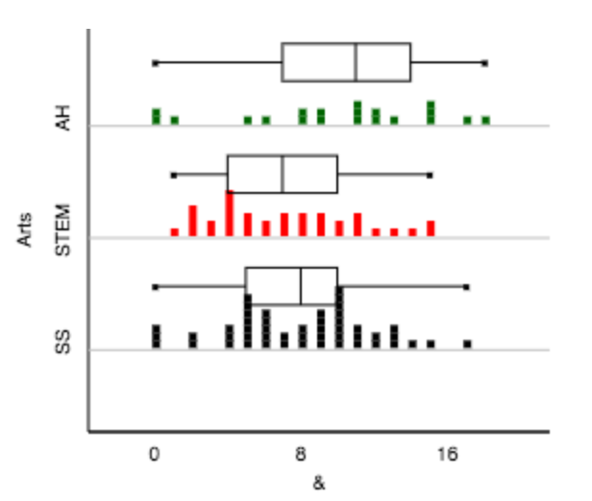

As seen in Figure 1, the distributions are not strongly skewed and there are no outliers. Using a simulation-based test with 5,000 repetitions and our MAD statistic of 1.849, we found a p-value of 0.0294 giving us strong evidence of an association between field of study and a person’s ability to memorize words. To further determine where this relationship lies, we found 95% confidence intervals for the pairwise differences, which are as follows:
SS-STEM: (-0.9689, 2.6700) SS-AH: (-4.14, 0.29) STEM-AH: (-5.09, -0.45)*

Results of Test 2: The relationship between brain lateralization and word memorization
In our second test, we looked to see if there was a relationship between a person’s dominant brain hemisphere and their ability to memorize words. The mean number of words memorized for left-brained participants was 8.35 (SD=4.00), for right-brained participants it was 8.71 (SD=4.63), and for equally brained participants it was 7.43 (SD=4.27).
Figure 2: The results for word memorization for left-brained participants are represented by the green bars in the top portion. The results for equally brained participants are represented in the middle in red, and right-brained participants are represented in black in the bottom portion. | 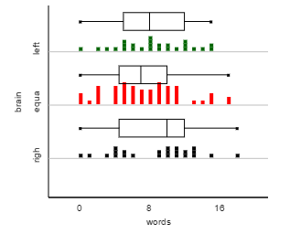
As seen in Figure 2, the distributions are not strongly skewed and there are no outliers. Using a simulation based test and our MAD statistic of 0.853, we obtained a p-value 0.4744. Therefore we do not have strong evidence that there is an association between a person’s brain lateralization and their ability to memorize words.

Discussion/Conclusion
For our test concerning field of study and word memorization, our results, especially the small p-value, allow us to conclude that there is an association. Based on our means, Art & Humanities majors scored the highest, while STEM majors scored the lowest, with Social Science majors scoring in-between. The only statistically significant difference was found between Art & Humanities majors and STEM majors, with a 95% confidence interval indicating that, for our population, Arts & Humanities majors were able to remember 0.45 to 5.09 more words on average than STEM majors. Based on our background research, our results for this test were not surprising; we expected Arts & Humanities, who spend much of their time reading and writing to score highest on the word memorization test.
Our second test looked at the relationship between brain lateralization and word memorization. With our large p-value, we could not conclude that there is an association between a person’s brain lateralization and their ability to memorize words. The means for each dominant brain hemisphere (left, right, equal) were very close, and the results were not statistically significant. Based on our background research, we had expected to see more significant results. For example, as Lombrozo stated, “[the right hemisphere] is...more able to later remember details about the words it encountered.” This, and other research, suggests that right-brained individuals would be more able to memorize words, while those who are left or equally brained would not be as able to recall words; however, our results did not show this, we did not find that there are significant differences in word memorization between dominant hemispheres.
There were some limitations leading to experimental variability that must be taken into account. For both tests, the data could have been distorted due to distractions during the memorization test, how much effort the subjects put into memorizing the words, how alert the subjects were (i.e. how much sleep they had the night before), or natural memorization ability. In addition, it may have been helpful to record each participant’s GPA. For the first test, subjects not knowing their major (undeclared) or being a double major could have affected the data. For the second test, accuracy of the left/brain right brain test could have affected the data, as some of our background research implied that such simplistic brain lateralization tests are often inaccurate. Moving forward, actions could be taken to potentially decrease the experimental variability and strengthen the study’s results.

References
Sternberg, Robert, "Human intelligence." Britannica School, Encyclopædia Britannica, 24 Feb. 2017. school.eb.com/levels/high/article/human-intelligence/106318#13346.toc. Accessed 11 Apr. 2017.
Lombrozo, Tania. "The Truth About The Left Brain / Right Brain Relationship." NPR. NPR, 02 Dec. 2013. Web. 11 Apr. 2017. <http://www.npr.org/sections/13.7/2013/12/02/248089436/the-truth-about-the-left-brain-right-brain-relationship>.
"Neuromyth 6." EDUCERI. N.p., n.d. Web. 12 Apr. 2017. <http://www.oecd.org/edu/ceri/neuromyth6.htm>

Appendix

Word Memorization test: http://www.braingle.com/mind/test_words.php
- Each word memorization test would generate a list of 40 five-letter words. Participants had 90 seconds, as counted down by a timer, to memorize as many words as possible. After the 90 seconds were finished, participants were given as much time as needed to type as many words as possible. Example pictures are below.
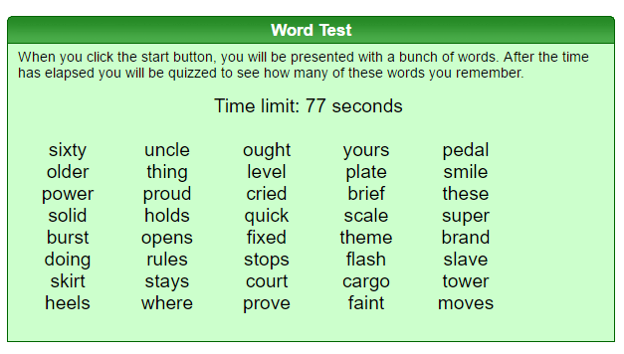

Brain Lateralization Test: http://braintest.sommer-sommer.com/en/
- The brain lateralization test took participants approximately 30 seconds to complete and presented them with a variety of questions (examples of which are below). Once the test was complete, the website would generate the results of the brain lateralization test, showing “left,” “right,” or “equal,” as well as the percentages of each.
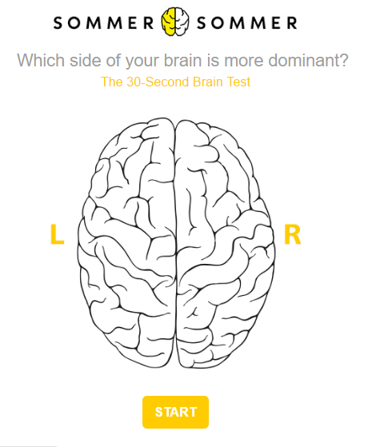
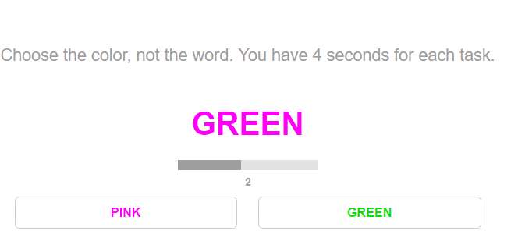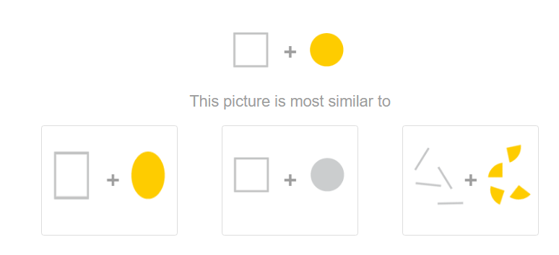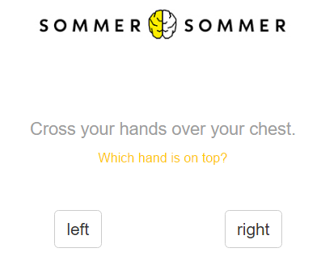

*please note that images of each question are not given, but rather examples of each type of question

Test 1: Examining the relationship between field of study and word memorization
We used the multiple means applet, which can be found at http://www.rossmanchance.com/ISIapplets.html, to do our analysis. Through simulated-based testing, we developed a null distribution of 5,000 trials and found our p-value to be 0.0294, using our MAD statistic of 1.849. Our confidence intervals were SS-STEM: (-0.9689, 2.6700), STEM-AH: (-5.09, -0.45)*, and SS-AH: (-4.14, 0.29).

Null: There is no association between a person’s field of study and their ability to memorize words.
- μ_{AH} = μ_{STEM} = μ_{SS}
Alternative: There is an association between a person’s field of study and their ability to memorize words.
- μ_{AH} ≠ μ_{STEM} OR μ_{AH} ≠ μ_{SS} OR μ_{SS} ≠ μ_{STEM}

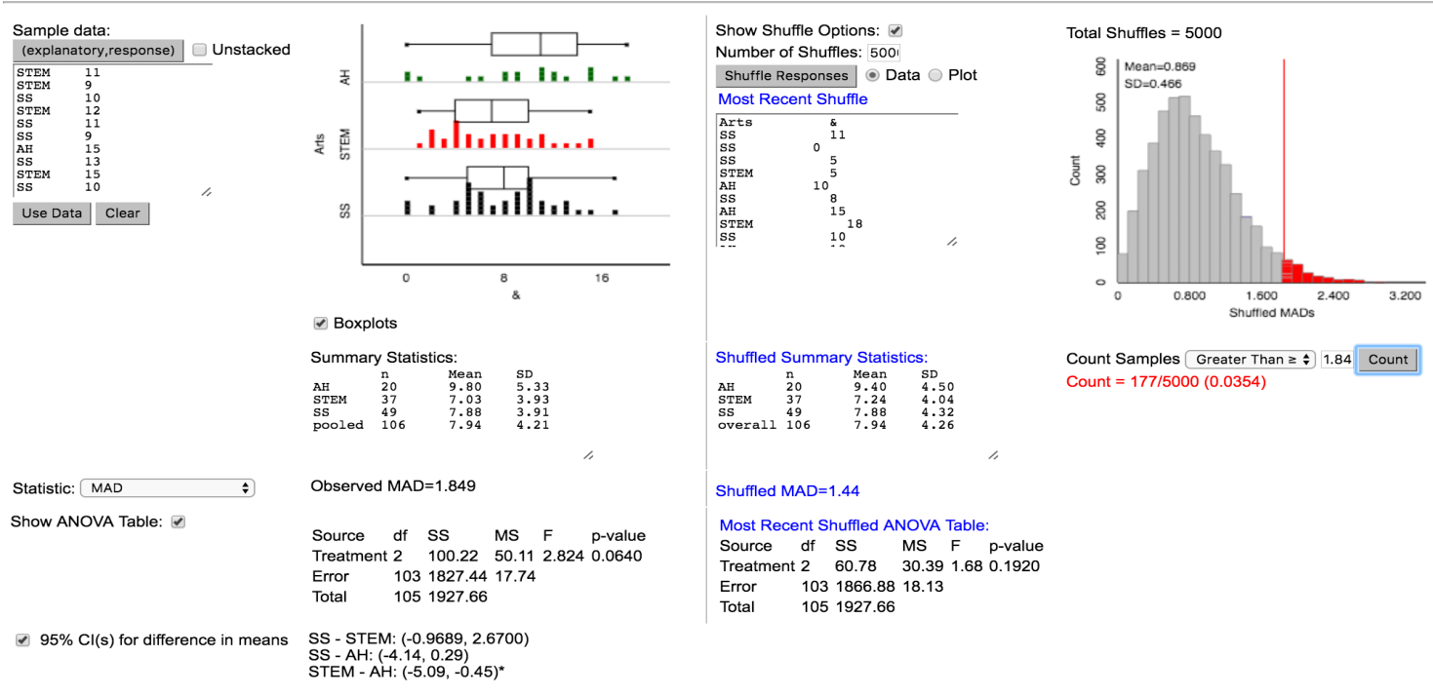

Test 2: Examining the relationship between brain lateralization and word memorization
We used the multiple means applet, which can be found at http://www.rossmanchance.com/ISIapplets.html, to do our analysis. Through simulated-based testing, we developed a null distribution of 5,000 trials and found our p-value to be 0.4744, using our MAD statistic of 0.853.

Null: There is no association between a person’s brain lateralization and their ability to memorize words.
- μ_{L} = μ_{R} = μ_{E}
Alternative: There is an association between a person’s brain lateralization and their ability to memorize words.
- μ_{L} ≠ μ_{R} OR μ_{R} ≠ μ_{E} OR μ_{L} ≠ μ_{E}

