Streptococcus Mutans Growth in Different Sugar Sources

Abstract:
Streptococcus Mutans is a bacteria which is known to contribute to the formation of plaque and cavities in the mouths of Homo sapiens. Due to this, one well known cause of cavity formation is consumption of high amounts of sugar, due to the additional nutrition from the sugars being utilized by the bacteria to expedite bacterial growth. Additionally growth can be variable based on the sugar source, due to each bacterial species having limits on how well they adapt to differing sugar sources. Knowing this, 20 Streptococcus mutans colonies were applied to 4 sugar sources, Sucrose, Glucose, Fructose and no sugar, so that n=5 colonies for each sugar source. These bacterial colonies were subsequently assessed every 15 minutes for growth. The questions asked were which sugar produces the most growth and which sugar produces the fastest growth? From this we conclude that the Sucrose nutrient source produced the most growth (p-value = <10^-16). Additionally, we concluded that different sugar sources will generate different rates of growth (p value= .0012). However we could not reject the null hypothesis that the rate of sucrose growth was distinct from the second highest value: the rate of glucose growth, as the p value presented for the Test of Equal Slopes was 0.15.

Introduction
In this experiment, 3 bacterial colonies of Streptococcus mutans were introduced to three different sugar sources: glucose, fructose, and sucrose and an additional sugar free control. Bacterial colony growth was measured by recording the change in light absorbance by the bacteria as time progressed using a spectrophotometer, and stages of bacterial growth are characterized by Figure 1, and uses a common industrial protocol (Quigley 2008) . Five trials were carried out with each type of sugar, and the slope of the linear portion of growth, which is known as the “Log Phase” (Widdel, 2007) was calculated for each trial. The first question that was investigated was: “which sugar source yielded the most cumulative bacterial growth?” The cumulative bacterial growth was defined as: “the point when absorbance ceased changing linearly; otherwise known as the end of the Log Phase.” It is referred to as cumulative growth because it takes both the lag phase and the Log phase into account. The end of the Log Phase occurred for all sugar sources at time=225. Due to this, overall growth could be assessed for all sugar types by comparing each group’s absorbance at t=225. The second question being asked was: “will the rates of growth be different among different sugar sources,” the last question asked was “is this growth rate be related to the bacteria’s maximum growth?” The rate of growth was assessed by observing 5 data points from Time=105 to Time=165. These points were chosen because they were in the center of the log phase, which minimizes chance of interfering data caused by the change of the colony to flat phases of growth. Slope was calculated by using the “lm” function of R Studio
In the experiment, the explanatory variable was the type of sugar. The response variables were the maximum growth at the end of Log phase, and the slope of the time vs absorbance during log phase. The hypothesis is that bacteria will grow the best on sucrose, since it is a disaccharide, Furthermore, we predict that slope will have a positive relationship with overall growth and we should see larger changes in time vs absorbance for bacterial colonies with higher overall growth.

Descriptive Data

The first Assessment of the Data was a descriptive assessment. Observing the Data in Figures 2 and 3, one can conclude that it is very likely that the slopes and the cumulative growth are differing based on sugar source . The Box plot analysis (Fig 1) depicts the low variance in each sample groups, and the linear graph (Fig 2) reveals the strong differences between slopes, additionally one can observe a very strong Pearson’s correlation (r= .985 for sucrose, .998 for glucose, .995 for fructose, .994 for control) and r squared value (r²=.970 for sucrose, .995 for glucose, .987 for fructose, .998 for control) for all 4 groups. Thus, a few conclusions that can be made from the figures are that the data contains large differences and small variance in growth measurement, and also the linear model of growth is a very strong predictor of bacterial growth as long as it remains in Log phase.
Fig 1
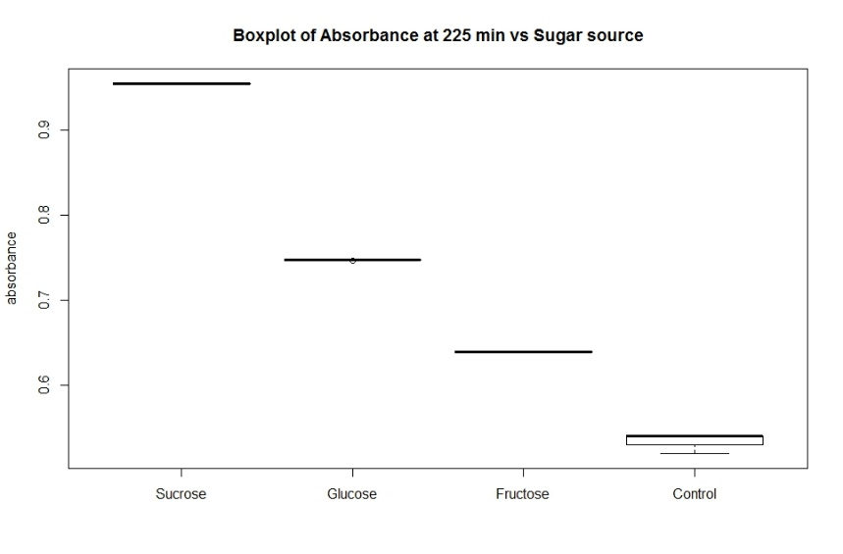
Fig 2

Testing For Cumulative Growth Using Anova and Tukey HSD Question 1
Additionally, statistical tests were run to determine whether observed growth differences were significantly different. For optimal growth, it was assumed that the data was normally distributed, and an analysis of variance test was done to test for difference among all groups at a the 5% level of significance. The ANOVA test was run on R, and returned a P value of <10^-16 for the null hypothesis of all cumulative growth being equal. Due to the ANOVA test, we can reject the null and conclude that the cumulative growth between all 4 groups is extremely different. Additionally, Tukey’s Honest Significance Difference test was calculated on R studio and returned a p adjacent of <10^-16 , and we would reject the null hypothesis of all data being from the same population. Therefore, it can be concluded that optimal growth is dependent on which sugar source Streptococcus Mutans receive, with Sucrose being the highest optimal growth, followed by glucose, than fructose, then control.
Testing For Linear Growth Using Test of Equal Slopes: Question 2
Fig 3

While the r and r² values verified the linear growth model as a good predictor of Streptococcus mutans growth behaviors in Log phase, there was a need to test whether slopes of growth differed from each other. The test that was used was “the test of equal slopes,” which was package that was additionally downloaded through R studio smartr package. The test assessed the average 5 values of each data point taken from a group (abs @ t=105avg, Abs @ t=120avg, etc.) and assessed the slope for all 4 groups. The times that were used from each group to produce the slope remained consistent with the times used to calculate the r and r² values (t 105 to t165). When testing all 4 slopes for null hypothesis that all slopes are equal, the p value = .0012, which results in a rejection of the null, and allows for the conclusion that the slopes are different. However when testing all values individually, the P value for Sucrose-Glucose had a p value of .189 and Fructose-Control had a p value of .778, while all other groups had slopes that differed at a p value of 10^-16. Therefore, it can be concluded that different sugar source will certainly have an effect on the rate of Log phase growth
Testing relationship between Cumulative growth and rate of growth in Log Phase: Question 3
As can be observed from the previous tests 1 and 2, there are statistically significant growth differences from each sugar group even when there are statistically similar slopes of Log Phase. One must conclude that there are other factors involved that will determine the final growth of the bacteria. One potential factor could be the differences in Lag phase, which as we see in the Figure 1, could modulate cumulative growth independently of the slope of log phase. Based on this, a correlation test was run on slope of each bacterial colony’s growth in Log phase (stated as a single value for each colony) vs that bacterial colony’s cumulative growth. The correlation value returned was .95, implying a heavy dependence on the rate of growth to determine the cumulative growth.
Conclusion
For the cumulative growth of Streptococcus mutans, it can be concluded that sugar source makes a significant difference at a p value of < 10^-16. Additionally, there is a difference in slope based on sugar source (p=.0012), but it cannot be concluded which sugar has the most growth. From this we can conclude that sugar source greatly affected the amount of cumulative bacterial growth, while we also conclude that glucose and sucrose yield quicker growth in bacteria than fructose and control samples at a 95% confidence interval. One final remark is a greater need to generate more measurements within the Log phase time period. This is because as more data points are generated for an average slope, the more robust the test of equal slopes becomes. This would allow for the rejection of the null for possibly all sugar types and distinguish their slopes as different.

References
Quigley (2008). Monitoring the Growth of E. coli With Light Scattering Using the Synergy™ 4 Multi-Mode Microplate Reader with Hybrid Technology™, Biotek Laboratories
Widdel, F. (2007). Theory and measurement of bacterial growth. Di dalam Grundpraktikum Mikrobiologie, 4(11).

