The Importance of Social Media
Presence in Kickstarter Success

David Leitson and Bao Tran

Abstract

Kickstarter is an online crowdfunding platform that allows project initiators to propose project ideas and receive donations from individuals who support the idea. Project initiators set a fundraising goal of the project and only receive the donated funds if the monetary goal is met. In order to determine the influence of social media on the success of Kickstarter projects, we performed an extra sum of squares analysis to determine the effect of social media presence on the success of Kickstarter campaigns (i.e. the percent of the goal that each project was able to fundraise). We found that including four variables related to social media presence influenced the success of projects at a statistically significant level. However, its practical significance is less patent.

- Background and Significance

Over the past decade, crowdfunding websites have grown exponentially in popularity and in their importance to entrepreneurial ventures. Crowdfunding has become such a vital fundraising practice that when President Obama signed the JOBS Act, a bill that legalized equity crowdfunding, he said, “For start-ups and small businesses, this bill is a potential game changer” (Alper, 2012). Despite this growth in usage, there has been little research on what factors influence the success of Kickstarter projects (Cordova et al., 2011).

Kickstarter is perhaps the most popular online crowdfunding platform, having raised more than $1.9 billion for more than 257,000 creative projects such as films, music, journalism, video games, and technology-related projects. The platform allows project initiators to propose project ideas and receive donations from individuals who support the idea. Project initiators set a fundraising goal and only receive the donated funds if the monetary goal is met. The question we sought to answer is whether a strong social media presence influences a project’s ability to raise funds. The social media factors we analyzed were: whether the project had a Twitter account, whether it had a Facebook account, its number of Facebook friends, and its number of Twitter followers. We hypothesized that these factors have a significant relationship with the percent of the goal that each project was able to fundraise.

- Description of Data and its Source

We obtained our data from the Kickback Machine dataset on bigml.com. The dataset contained information on every Kickstarter campaign that began between April and December 2012 and ended after mid-June 2012. We excluded all campaigns with a goal less than $500 and greater than $50,000 in order to focus on the most common type of Kickstarter projects. Additionally, since our response variable was the percent of the goal that each project was able to fundraise, campaigns with a goal of $1 skewed the analysis in a way that is not reflective of our goal. The dataset had a total of 13,937 observations. A description of the variables is listed in Table 1 in the appendix.

- Methodology

We initially used best subsets analysis and evaluated multiple residual plots to create a reduced regression model to predict the success of a project, defined as the percent of the goal that each project was able to fundraise. To create this reduced model, we excluded the variables related to social media presence in the best subsets analysis. We then analyzed the normal probability plot of this model’s residuals to check the extra sum of squares test assumption that the error terms follow a normal probability distribution. Our residual plots revealed that the distribution of the residuals lacked normality. We found that a log transformation to the response variable and the following explanatory variables greatly improved the distribution of the residuals: goal, updates count, backers count, average pledge per backer, reward count, and minimum reward.

Figure 1 in the appendix compares the normal probability plot before and after the log transformations. The residual plots demonstrate that the distribution of the residuals is less skewed after the transformations. Nevertheless, the normal probability plot is still far less than desirable. We attempted multiple transformations of the response variable to improve the normal probability plot including a log of the log, a square root of the log, and an inverse of the log transformation. Unfortunately, none of these transformations improved the distribution of residuals.

We created a full model by adding the following four variables related to social media presence to the existing reduced model: whether the project had a Twitter account, whether it had a Facebook account, its number of Facebook friends, and its number of Twitter followers. We ran the extra sum of squares test comparing the reduced model and the full model. Our goal was to analyze whether the difference in the R² value between the two models was large enough to assume a statistically significant relationship between the explanatory variables related to social media presence and the response variable, the percent of the goal raised.

- Results and Discussion

For our test of the influence of social media presence on the response variable, we found the following: R²_{Reduced} = .7573, R²_{Full} = .7578. The extra sum of squares test between these two models yielded an F-statistic that corresponded to a p-value smaller than .001. Therefore, the inclusion of the variables related to social media presence significantly improved the model at a level of .001.

Although the extra sum of squares test indicates that social media presence is a statistically significant variable, the minimal change in R² suggests that social media presence may not be of practical significance in determining a project’s success. Figure 2 contains four graphs in which four social media presence variables are plotted against the log of percent of goal. Even though we have a small p-value, the four graphs show that there is no clear relationship between the four social media factors and the response variable. This is consistent with the minimal increase in the R² value.

Figure 2. Four Social Media Variables vs. Log of Percent of Goal Raised

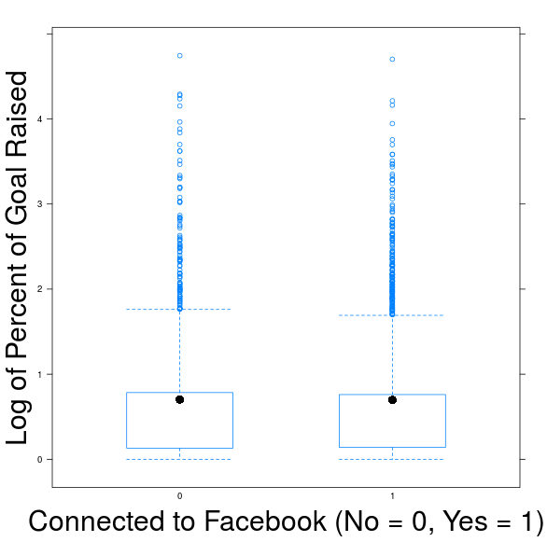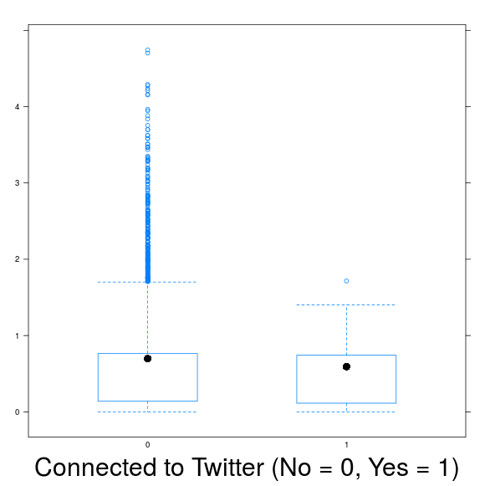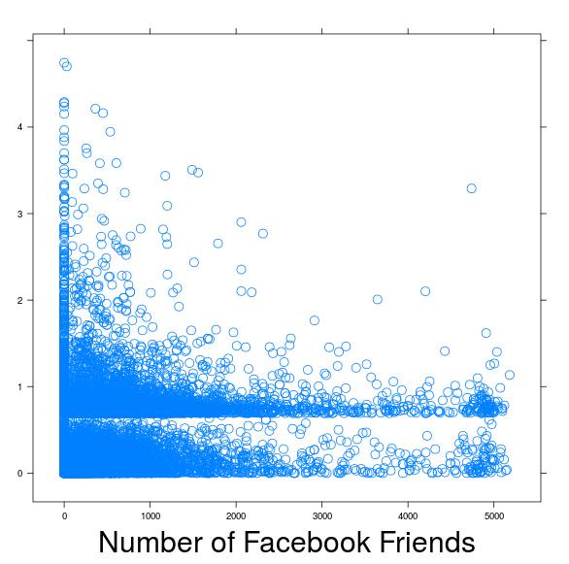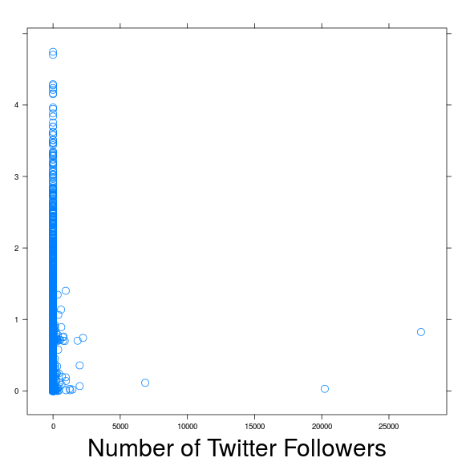

Table 2 in the appendix further underscores the lack of practical significance in regards to whether the project had a Twitter account, whether it had a Facebook account and its number of Twitter followers. In fact, a slightly higher percentage of unsuccessful campaigns have a Facebook account and a Twitter account. Additionally, unsuccessful campaigns have, on average, more twitter followers than successful campaigns. However, the data regarding Facebook friends tells a different story. Successful campaigns tend to have, on average, 114.8 more Facebook friends than unsuccessful campaigns.

The following figure shows that the importance of Facebook friends increases as the goal increases. The disparity in Facebook friends between successful campaigns and unsuccessful campaigns becomes more pronounced as the goal increases. Our data does not suggest that Twitter has much practical significance, regardless of the number of followers. On the other hand, the extent of a project’s presence on Facebook is a significant factor in its success, especially if the goal is relatively large.

Figure 3

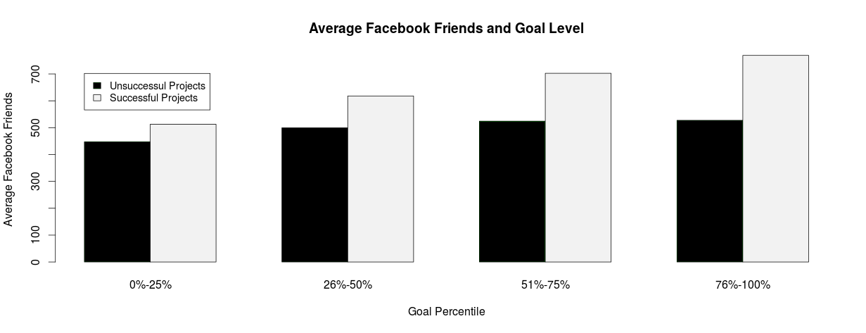

This observation -- that the importance of Facebook friends increases as the goal increases – is intuitive. It makes sense that as people attempt to raise larger sums of money, social media presence becomes especially important because it allows project initiators to connect with a larger network of potential backers. Had we included an interaction term between Goal and Facebook Friends in our full model, we likely would have observed a more significant increase in the adjusted R² value.

In conclusion, the results of this study were compatible with our initial hypothesis. Factors related to social media presence have a significant relationship with the percent of the goal that each project was able to fundraise. However, the practical significance of this relationship is negligible, with the exception of the number of Facebook friends. Future research should explore the interaction between social media presence and other relevant variables. This analysis may yield a more nuanced understanding of the practical significance of social media presence.

- Appendix

Table 1

Name of variable | Description
Explanatory variables included in reduced model
Goal | Targeted amount of money to be raised, measured in dollars (quantitative)
Parent category | Type of project (categories: Arts, Comics, Dance, Design, Fashion, Films & Videos, Food, Games, Music, Photography, Publishing, Technology, Theater)
Reward count | Number of rewards offered in return for contributions (quantitative)
Updates count | Number of updates on the project’s page (quantitative)
Backers count | Number of backers for the project (quantitative)
Comments count | Number of comments on the project’s page (quantitative)
Average pledge per backer | Average amount of money raised per backer, measured in dollars (quantitative)
Video | Whether the project’s page featured a video (categories: yes = 1, so = 0)
Minimum reward | Minimum amount of reward, measured in dollars (quantitative)
Explanatory variables related to social media presence
Facebook account | Whether the project is connected to a Facebook account (categories: yes = 1, no = 0)
Facebook friends | How many friends the account has on Facebook (quantitative)
Twitter account | Whether the project is connected to a twitter account (categories: yes = 1, no = 0)
Twitter followers | Number of twitter followers (quantitative)
Explanatory variables included in stepwise analysis, not included in reduced model
Maximum reward | Maximum amount of reward, measured in dollars (quantitative)
USA | Whether the project is held in the USA (categories: yes = 1, no = 0)
Duration | Number of days between the launch date and deadline date (quantitative)
First-seen-in | What page the project was first seen (categories: recently launched, ending soon, none)
Has video | Whether the project’s page featured a video (categories: yes = 1, no = 0)
Deadline date -month | Day of month of deadline (categories: June, July, August, October, November, December, January, February)
Deadline date - day of week | Day of week of deadline (categories: Monday, Tuesday, Wednesday, Thursday, Friday, Saturday, Sunday)
Launched date – month | Day of month of deadline (categories: April, May, June, July, August, October, November, December)
Launched date – day of week | Day of week of launch (categories: Monday, Tuesday, Wednesday, Thursday, Friday, Saturday, Sunday)

Figure 1
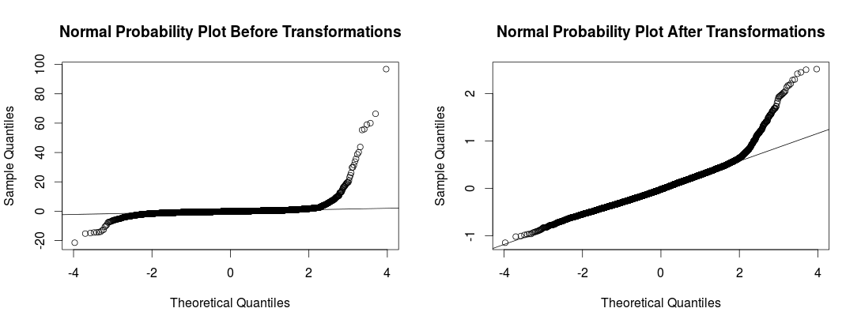

Table 2

 | Percent with a Facebook Account | Percent with a Twitter Account | Number of Facebook Friends | Number of Twitter Followers
Unsuccessful | 76.3% | 2.9% | 504.6 | 7.8
Successful | 75.8% | 2.3% | 629.9 | 5.4

- References

Alper, Alexandra. "Obama Signs Bill to Boost Business Startups." Reuters. Thomson Reuters,
05 Apr. 2012. Web. 09 Dec. 2015.

Cordova, Alessandro, Johanna Dolci, and Gianfranco Gianfrate. "The Determinants of Crowdfunding
Success: Evidence from Technology Projects." Procedia - Social and Behavioral Sciences 181 (2015): 115-24. Web.

"Kickstarter." Stats —. N.p., n.d. Web. 11 Dec. 2015.

See the appendix for larger images of the plots.

