Effect of music type, gender, and learner type on auditory comprehension

Abstract:

The purpose of this study was to evaluate the effect that differing musical genres, gender, and learner type have on auditory comprehension. This was tested by having instrumental or popular music playing while the participants walked in a room and were read aloud a story. Participants were then administered an auditory comprehension questionnaire based on the story. It was found that the music genre (p-value = 0.4942) and gender (p-value = 0.4876) had no significant effect on reading comprehension, but the learning type of the individual did have a significant effect (p-value = 0.034). Our experiment demonstrated that while music type and gender played a non-significant role in auditory comprehension, individuals’ predisposed learning type may significantly effect on their ability to comprehend and interact with auditory information.

Background and Significance:

Comprehension in any realm of work is vital, and it is important to understand how it can be influenced by external factors such as music. While completing tasks, individuals may play music to pass the time and make their task more enjoyable. Hearing music while performing tasks is pleasurable, but working while playing background music has been linked to a decrease the quality of task performance (Furnham & Bradley, 1997). Although listening to music may negatively affect an individual’s performance, the effect varies with different types of music (Furnham & Bradley, 1997; Perham & Currie, 2014). For instance, it was found that playing no music or instrumental music will increase reading comprehension, in comparison to playing vocal music (Perham & Currie, 2014). While any music may decrease task performance, instrumental music has been found to harm the individual’s performance less than other varying types of music (Perham & Currie, 2014). However, Freeburne and Fleischer (1952) found that listening to different genres of music, such as instrumental, pop, or jazz, does not necessarily affect reading rate, comprehension, or intelligence. This finding has brought about a conflicting result, pertaining to whether or not different types of music actually have a negative or no effect on auditory comprehension.
It has been found that instrumental music or no music has a lesser negative effect on reading comprehension and that different genres of music do not necessarily affect how an individual reads and comprehends (Freeburne & Fleischer, 1952; Furnham & Bradley, 1997; Perham & Currie, 2014). The current experiment attempted to explore how differing genres of music can alter an individual’s comprehension while also paying attention to other demographic characteristics. The study compared two different musical genres, popular and instrumental, in order to determine if listening while completing a task actually causes a difference in auditory comprehension. It was hypothesized that those hearing instrumental music would have a higher auditory comprehension score than hearing popular music. Also, it was hypothesized that females and males will have the same auditory comprehension scores. Finally, it was hypothesized that self-reported auditory listeners will have a higher auditory comprehension score than visual and tactile learners.

Methods:

Data collection
Participants in this study were college students from Biola University. The data was collected November 9, 2015 and November 11, 2015. There were 55 students that participated. The mean age of the participants was 20.5 (SD = 4.7). Of the participants, 83.6% were female while 16.4% were male. The participant’s ethnicities were 30.9% Caucasian, 29.1% Hispanic, 20.0% Asian American, 10.9% Asian, 3.6% African American, and 5.5% another ethnicity that was unspecified. The students were recruited using Sona Systems, which allowed each participant to receive one extra credit point towards an approved Psychology course of their choosing. Two students were excluded for with not responding to the learner type item. Also, those students who did not arrive to the experiment on time were asked to leave.
Variable creation
Recall that the manipulated variable that was tested was the effect of the genre of music on auditory comprehension. Type of music was divided into two levels: popular and instrumental. The songs that were classified under the popular genre were songs that were commonly heard with lyrics that were played frequently on the radio. Instrumental music was defined as songs without lyrics that may not be commonly heard. The only quantitative variable is measured by the auditory comprehension score. Auditory comprehension is the ability to understand and remember information from a certain text regardless of the means in which the information is being shared. In order to understand the effect of music on auditory comprehension, auditory comprehension was measured using a 15 multiple choice question quiz based on a short story that was read aloud to the participants. The story was from Tanzania, and therefore it was very unlikely that any participant had been previously exposed to it. Participants self-reported their gender as well as the type of learner they were.
Analytic methods
The statistical procedures that were used to analyze the data were a histogram, box plots (appendix), Shapiro-Wilk Test for Normality, Normal Q-Q Plot (appendix), t-tests, One-Way ANOVA, and Tukey HSD tests. A histogram was used to show the distribution of the frequency of participants who obtained a specific number of correct answers on the auditory comprehension questionnaire scores. The Shapiro-Wilk normality test and the Normality Q-Q plot were used to check for normality. The independent t-tests told us if there was a significant difference between auditory comprehension and gender as well as auditory comprehension and music type. A One-Way ANOVA was used to analyze if the learner type of a person affected their auditory comprehension score.

Results:

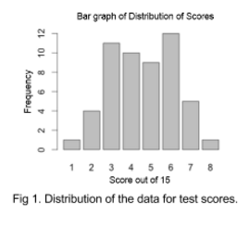
Descriptive Statistics
The majority of our participants were females (83%). The most common self-identified learner style was visual learners (60%), followed by tactile (28%). By random chance, fewer people signed up for the instrumental music day, which caused a large difference in the representation for the variable, 19 instrumental to 34 popular (Table 1).
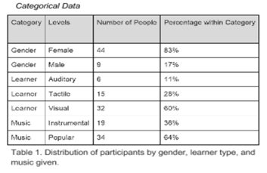
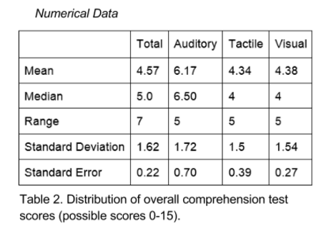
The mean score for all participants was 4.566 correct answers with a standard deviation of 1.623 and standard error of 0.223 (Table 2). In the bar graph (Fig. 1), the range of the answers are shown to be 1 to 8, although the response score could have gone up to 15. The scores that people most frequently achieved were between 3 and 6. While the data is not perfectly normal, it does roughly resemble a normal curve. This along with other tests for normality (see appendix) lead us to believe that the data is normal enough to use in the hypothesis tests.

Inferential Statistics
We followed up the descriptive statistics with two independent t-tests and an ANOVA test. In the first t-test performed, the null was no difference in learner scores between males and females. We obtained a p-value of 0.4876 > 0.05 (t = -0.72103). Our data suggests that the null should not be rejected, meaning males and females do not comprehend the story better or worse than the corresponding gender.
The second t-test compared auditory comprehension scores and music (H_{O} = Type of Music does not affect scores, μ_{popular}=μ_{instrumental}). The obtained p-value was 0.4942 > 0.05 (t = 0.69211), therefore we retain the null. This means that there is no difference in the auditory comprehension with popular and instrumental music.
Then we conducted a One-Way ANOVA test to see if there was a significant difference for the types of learners. This resulted in a p-value of 0.034 < 0.05. We did a follow up Tukey test to examine the specific differences between the three categories. For this test, the Tactile-Auditory comparison was significant with a p-value of 0.046 with the auditory group having significantly higher scores than the tactile group. Another comparison, Visual-Auditory, was significant with a p-value of 0.032 with the auditory group having significantly higher scores than the visual group. The final comparison was between Visual-Tactile with a p-value of 0.9959 and was therefore not significant. This shows that the auditory learners were better at auditory comprehension than the others. The Tukey HSD showed that the CI for Tactile-Auditory was between -3.64 and -0.028 while the CI for Visual-Auditory was between -3.45 and -0.13.

Discussion/Conclusions:

We attempted to answer the question of whether there is an effect of music on auditory comprehension scores. We found that there was no significant difference in mean auditory comprehension scores of the instrumental and popular music groups (p-value = 0.4942). This is what the main questioned was focused on, and it was also opposite of our hypothesis. We originally thought that instrumental music would have been more conducive to a learning environment, resulting in better comprehension scores, based on previous data supporting this (Freeburne & Fleischer, 1952; Furnham & Bradley, 1997; Perham & Currie, 2014). We also thought that it would be easier to listen to a story and pay attention in a more calming environment. We hypothesized that popular music (which included singing) would be a competing voice to listen to, therefore making it more difficult to pay attention to the story. From the data collected, it appears that our hypotheses were incorrect, and that the type of music has very little effect on the level of auditory comprehension.
In one of our other two hypotheses, we predicted that males and females would have the same or similar scores. The results of our Scores to Gender t-test supported our hypothesis (p-value = 0.4876). This also could have been affected by uneven sample sizes (Females = 44, Males = 9), so the results of this test were less powerful than we would have liked.
Our final hypothesis was that auditory learners would have higher test scores since the story was read aloud to them. It was expected that students who were able to learn best by listening would have produced higher verbal comprehension scores overall. The data we collected supported this hypothesis. The Tukey test revealed that the auditory group had significantly higher scores than either visual or tactile, as stated previously. These findings show that the type of learning style a person exhibits results in a large difference in verbal scores.

References:

Freeburne, C., M., & Fleischer, M., S. (1952). The effect of music distraction upon reading rate
and comprehension. Journal of Educational Psychology, 43(2). 101-109. doi: 10.1037/h0054219
Furnham, A., & Bradley, A. (1997). Music while you work: The differential distraction of
background music on the cognitive test performance of introverts and extroverts. Applied Cognitive Psychology, 11(5). 445-455. doi: 10.1002/(SICI)1099-0720(199710)11:5<445::AID-ACP472>3.0.CO;2-R
Perham, N., & Currie, H. (2014). Does listening to preferred music improve reading
comprehension performance? Applied Cognitive Psychology, 28(2). 279-284. doi: 10.1002/acp.2994

Extended Appendix:

Test for Normality:
For our overall data, we conducted a Shapiro-Wilk test for normality. Our obtained p-value was 0.034, which showed that that the data was slightly not normal. To confirm this we made a Normal Q-Q plot (Fig 2). The Normal Q-Q plot appeared more normal that we had anticipated, which was a good sign. Just to be safe we attempted to transform the data to see if it could still be improved.
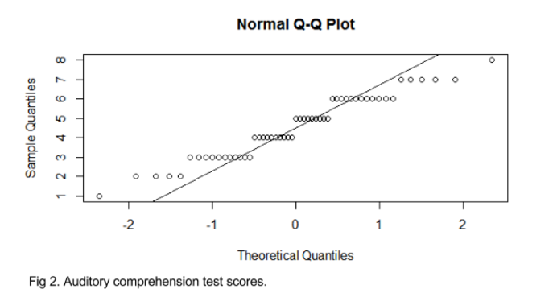
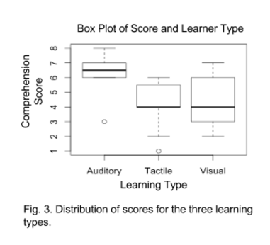
Several transformations were attempted, however, nothing we tried helped at all. In fact all attempted transformations made the normality of the data much worse. Without any transformations the Shapiro-Wilk Normality test p-value was very close to 0.05. Because of this, and because the shape of the distribution was already mounded, the Normal Q-Q plot appeared relatively normal, we considered the data good enough to continue with our t-tests. The violation was not so much the shape, but the discreteness of the data.

Box Plots of Distribution of the Data:
Score vs. Learner Type
According to this multiple box plot (Fig 3), the largest spread is among the visual learners. However the mean score is the same for both Tactile and Visual. This shows that the big spread in the visual learners doesn’t make a difference to the mean scores. The mean of the auditory learners was higher than the others, suggesting they had better audio comprehension than the tactile and visual learners.

Score vs. Gender
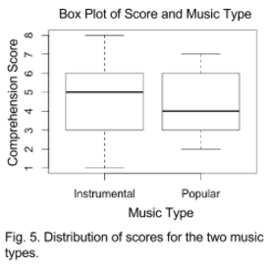
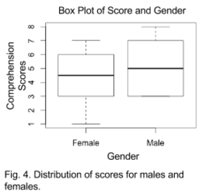
This multiple box plot of gender (Fig 4) shows that the males had a larger spread, which really doesn’t mean anything. Because there were so many more females that participated, the data is badly skewed. Even so, the mean scores for both genders is still about even, suggesting that there is not much of a difference in the auditory comprehension capabilities of one gender over the other.

Score vs. Music Type
This multiple box plot for score and music type (Fig. 5) shows that there was a larger spread for the instrumental music. The mean for both instrumental and popular music were pretty close, but there is enough of a difference between the two to warrant further investigation.

Demographic Questionnaire

Please answer all of the following questions as they best describe you.
Gender (circle one): Female Male
Age: ____________
Religion (circle one):
Evangelical Protestant Presbyterian Roman Catholic Non-denominational
Other: ________________________
Ethnicity (circle one):
African American Asian American White, Non-Hispanic White, Hispanic
Middle Eastern Other: _______________
Culture you identify with: _______________________
Preferred music taste (circle one):
Popular Rock Rap Instrumental/Classical Hip Hop
R&B Alternative Indie Other: _______________
Type of learner (circle one):
Auditory Visual Tactile Other: ________________

Reading Comprehension Questionnaire
Please circle the best answer for each question.

1. What did Shindo learn from her experience?  - to be careful what she called her children  - to work harder  - to never wish for children  - how to provide for herself  2. What happened to Kitete after Shindo yelled at him?  - he apologized and worked harder  - he laughed  - turned back into a gourd  - he cried  3. Who came down to answer Shindo’s prayers?  - God  - an angel  - messenger from the great mountain spirit  - the town musician  4. Where was her husband?  - he passed away  - he divorced her  - he went to the store  - he went to another country  5. How long did it take the gourds to grow?  - one year  - one month  - one day  - one week  6. What did Kitete always do when he turned into a child?  - stood by the fire with a grin on his face  - played with the other children  - roamed around outside  - helped around the house  7. What did Shindo originally plan to do with the gourds?  - use them for crafts  - sell them at the market  - have them turn into children  - use them for bowls at home  8. When would the gourds change form into children?  - when Shindo was in the bathroom  - when Shindo left the house  - when Shindo was cooking  - when Shindo was sleeping | 9. What setting does the story take place in?  - farm  - ocean town  - mountain village  - industrial area  10. How did the children best benefit Shindo?  - helped with work around the house  - they went to town with her to buy vegetables  - they cured her loneliness by giving comfort and happiness  - they gave her energy so she wouldn’t be tired  11. What happened to the pot that Shindo was carrying?  - she made stew with it  - she was pushed and dropped it  - she put the pot down  - she tripped, dropped it and it shattered  12. What was Shindo’s main hobby?  - sewing  - tending the field  - cooking for the village  - tending to her children  13. Where was Shindo living?  - a house  - a hut  - an apartment  - a mansion  14. What made Kitete slow witted?  - he was smaller than the others  - he was younger than the other children  - he was dropped  - he was the only one dried by the fire  15. What limitation did Kitete have?  - he did not do work  - he was not as smart as the others  - he was seen as useless  - all of the above

