The Effects of Race, Gender, and Year on Frisking in New York City
Abstract:
New York’s stop-and-frisk law is a law enforcement tactic allowing police officers to stop individuals if they reasonable suspicion of a crime and frisk them in search of weapons or other contraband. In 2013, the Center for Constitutional Rights filed Floyd et al. v New York City on the basis of the New York Police Department’s practices of racial profiling and unlawful stopping (Center for Constitutional Rights, 2016). The judge ruled that the NYPD’s stop-and-frisk law was unconstitutional and ordered it to be remediated. In order to determine if the newly remediated law eradicated racial profiling and unlawful stopping, we analyzed data of the race and gender of all individuals frisked in 2012 and 2014. We found that black and Hispanic people were frisked most often and that there were more frisks in 2012 than in 2014. However, because the percentage of black and Hispanic people from the population of New York City that were frisked remained the same, we concluded that the law did not achieve its goal of ending racial profiling in stop-and-frisks.

The Effects of Race, Gender, and Year on Frisking in New York City

Background and Significance
A frisk is defined as a pat down of the outer garments in search of a concealed weapon. The New York stop-and-frisk law allows law enforcement to stop anyone they reasonably suspect has committed or is about to commit a crime. It also states that if a police officer who stops an individual reasonably suspects potential danger of physical harm, he or she may search the suspect for weapons or other contraband (NY Crim Pro L § 140.50). Stop-and-frisk was initially believed that it would reduce the number of guns and drugs on the streets of New York City (Brown, 2013); however, that has been proven to be untrue.
The law leads to harassment, humiliation, and blatant racial profiling of the citizens of New York City (Koehler, 2013). About 90% of those who are stopped are innocent (New York Civil Liberties Union). This violates their fourth amendment right under which they are protected from unreasonable searches and seizures (American Civil Liberties Union, 2016). About 90% of all people who are stopped are black or Hispanic (New York Civil Liberties Union). In this scenario, a person’s fourteenth amendment right is violated under which all citizens are equally protected under the law (American Civil Liberties Union, 2016). In 2013, the judge in Floyd, et al. v City of New York ruled that the New York Police Department’s stop-and-frisk law was unconstitutional and it was to be remediated (Koehler, 2013). Currently, the law does not allow police officers to stop individuals who match a “generalized description of a crime suspect” or those who make “furtive movements” (Cohen and Golding, 2015).
Our study aims to uncover the effects the court ruling had on stop-and-frisk tactics by examining frisking. The goal of the new law was to eradicate racial profiling and unconstitutional stopping of its citizens. To explore whether or not the change in the law has affected stop-and-frisk, we analyzed data containing details of all people frisked before and after the court ruling. The data was categorized by race and gender of individuals frisked.
Our null hypothesis is that there is no difference in the mean number of people frisked of all genders and races in 2012 and 2014. Our alternative hypothesis is that there is a difference in the mean number of people of each race and gender frisked in 2012 and 2014. If we are able to reject our null hypothesis, we can conclude that the court ruling did indeed fulfill its purpose in reducing unlawful frisking and racial profiling in New York City.

Methods
Data Collection
We used frisked data provided by the New York City Police Department for 2012 and 2014.

Variables
We looked at gender, race, and year and their effect on the number of people frisked in New York City.
- Race: Asian, Black, Hispanic, Native, Other, White
- Gender: Male, Female
- Year: 2012, 2014

Analytical Methods
We used an ANOVA test to examine the two-way and three-way interactions between our three variables as well as their individual effects on frisking in New York City. In order to perform an ANOVA, we had to take into account the model assumptions. However, our data is not an independent simple random sample because we have the complete frisked data for the population of New York City. We did a log transformation (ln(x+1)) of our data in order to satisfy the assumptions of equal variances and no extreme outliers. However, even when doing a log transformation, we cannot assume either assumption. Despite this, it is unlikely that they will have an effect on our analysis and results because our sample size is so large.
We also performed six two-proportion tests to examine the percentage of people of each race frisked out of the total in 2012 and 2014. In order to perform a two proportion test, we needed to satisfy the model assumptions. Our X₁ and X₂ were greater than or equal to five as were N₁ – X₁ and N₂ – X₂.

Results
In our experiment we analyzed stop-and-frisk data from New York City to determine if a relationship between race, gender, and year existed. Figure 1 illustrates that race, gender, and year individually exhibited statistically significant results. Black and Hispanics were frisked most often (p<0.005, F=54.92), more people were frisked in 2012 than in 2014 (p<0.005, F=58.60), and more males were frisked than females (p<0.005, F=24.78). Figure 2 illustrates the percentage of racial distribution of NYC in the 2010 census and the racial distribution of all frisks in 2012 and 2014. Our two proportion tests showed that there was not a significant difference in the percent of black people (p=.771) and Hispanic people (p=.513) frisked in 2012 and 2014.

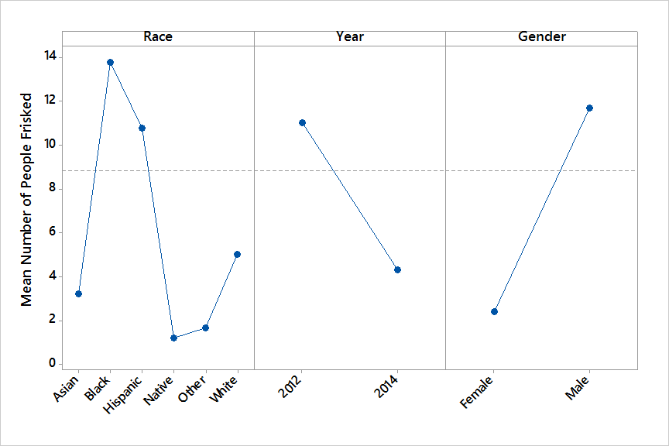
Figure 1. The main effects plot of mean of people frisked in New York City with regard to race (F=54.92, df=5, p<0.005), year (F=24.78, df=1, p<0.005), and gender (F=58.60, df=1, p<0.005).
Figure 2 A bar chart comparing 2010 census data to frisked data in 2012 and 2014. A two proportion test showed the difference between Asian (p=.169), Black (p=.771), Hispanic (p=.513), Native (p=.044), other (p=.958), and White (p=.093) individuals.
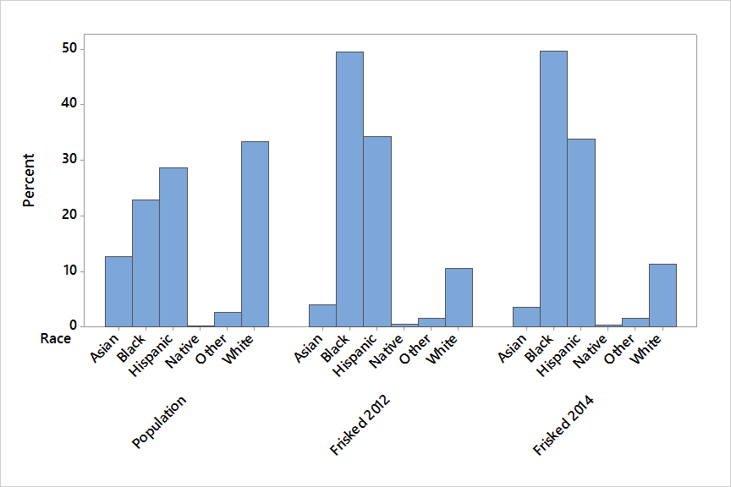
Discussion
We rejected our null hypothesis and concluded that there is a difference between the mean numbers of people frisked based on their race, gender, and the year they were frisked. We found that when looking at just one variable, significantly more black people were frisked than any other race, followed by Hispanic people, white people, Asian people, and those described as “other.” There were also more males frisked than females, and more people frisked in 2012 than in 2014. These results confirm our assumption that the change in the law did in fact reduce the amount of unlawful frisking of the citizens of New York City.
However, when looking at the one proportion of people frisked by race in 2012 and 2014, the proportions remained the same. Figure 2 exhibits the racial profiling problem within New York City by showing that people in NYC are not proportionately frisked. This proves that a significant racial profiling problem still exists even after the change in the law.
The results could have been affected by confounding variables such as the time of day the frisk occurred, the age and socioeconomic status of the frisked individual, as well as current events and incidents in the city. Current events regarding racial discrimination and profiling occurring across the country in different cities could also affect the data as it mounts pressure on law enforcement personnel. This study may not be utilized in other cities as not all cities have similar laws. The region and culture of the city can also play a substantial role.
Additional research could be done to analyze the relationship between a police officer’s race and the race of people frisked to further research on racial profiling. Research could also be done in cities with similar laws to better analyze the disconnect between law enforcement and its citizens of color.
References
American Civil Liberties Union. (2016). Know your rights: The United States Bill of Rights – First 10 amendments to the Constitution. Retrieved from: https://www.aclu.org/united-states-bill-rights-first-10-amendments-constitution

Brown, O. (2013). The legal murder of Trayvon Martin and New York City stop-and-frisk law: America’s war against black males rages on. The Western Journal of Black Studies, 258-270.

Center for Constitutional Rights. (2016, March 23). Floyd, et al. v City of New York, et al. Retrieved from: http://ccrjustice.org/home/what-we-do/our-cases/floyd-et-al-v-new-york-et-al

Cohen, S., Golding, B. (2015, March 3). Stop-and-frisk law so strict, cops should ‘travel with an attorney’. New York Post.

Koehler, R. (2013, August 15). Stop and frisk. Huffington Post.

New York Civil Liberties Union. (n.d.). Stop and frisk-campaign: About the issue. Retrieved from: www.nyclu.org/issues/racial-justice/stop-and-frisk-practices

