**Upvote or Downvote**

**What Makes Yik Yak Posts Popular?**

**Abstract:**

Yik Yak is a recently developed anonymous social media platform that users can access via a smartphone app. In order to determine potential indicators of popularity in Yik Yak posts, we examined which kinds of posts received the highest number of votes and comments. Posts were categorized as either a question or not and rated on a scale of 1 to 3 based on the following variables: humor, academic, love life relevance. We found that non-question posts had significantly higher amount of votes. We also found that there was a significant interaction effect between the question category and the academic scale.

**Background and Significance**

The popularity of social media sites has been exponentially growing over the years, and the newly developed social media app, Yik Yak, has become a part of the frenzy. Yik Yak allows users to post a maximum of 200 characters and vote or comment on other user’s posts in a 1.5 mile radius (Dewey 2014). Each post receives a cumulative total of votes, encompassing the upvote and downvotes given by other users. The creators have set up safeguards including the ability to flag inappropriate posts and obtain the identity of the user if the post is deemed a threat (Dewey 2014).

With over one million users, Yik Yak has not only become popular among college-aged adults, but also younger individuals in high school (DeAmicis 2015). This has become an issue as cyber bullying and threats of violence are increasingly common, as a result of the anonymous nature of Yik Yak (Valencia 2013). This has led institutions to block access to Yik Yak from their Internet servers. Defending the app, co-creator Brooks Buffington, states, "Anonymity can be a really beautiful thing, and one of the reasons we made it anonymous is it gives people a blank slate to work from, so you're not judged on your race or sexuality or gender. On Yik Yak you are purely judged on content you create." (Valencia 2013).

Our study aims to further understand what makes Yik Yak and its posts so popular, despite the shortcomings previously mentioned. There have yet to be studies determining what makes certain kinds of posts on Yik Yak popular, as the media focus has been upon the negative aspects of this social media platform. Therefore, we examined Yik Yak posts on a college campus, categorizing posts as either questions or non-questions and rating posts on a scale of 1-3 based on the following variables: humor, academic, and love. We quantified our response variable, popularity, by recording the cumulative number of votes and comments of each post.

Our null hypothesis is that there is no difference in the mean amount of votes or comments on a post between the levels of each of the variables: humor, love, academics, and question. There is also no interaction effect between these variables. Our alternative hypothesis is that the number of votes or comments a post has is dependent on the levels of at least one of the variables: humor, love, academics, and questions. There may also be an interaction effect between these variables. We predict that posts that rate high on the humor and love scale will receive a high number of votes, and therefore be more popular. We also predict that the posts that were questions would receive more comments.

**Methods:**

*Data collection:*

We collected data on our college campus at five different times each day for one week from Sunday through Saturday. We recorded the last five Yik Yak posts, under the “New” list, at 8am, 11am, 3pm, 6pm, and 9 pm each day.

*Variables:*

We recorded the number of votes and comments for each post. We also categorized the posts based on whether or not they were questions. Then, we went through and rated each post on a scale of 1 to 3 based on the variables of humor, academics, and love.

* Humor: 1=not meant to be funny, 2=sort of funny, 3=hilarious
* Academics: 1=no mention of anything school work related, 2=related to academia, 3=the post is mainly about academia
* Love: 1=no mention of anything love related, 2=mentions love, but is not the only aspect, 3=post is mainly about things love related (including sexual things)
* Question: Y= the post is a question, N= the post is not a question

*Analytical Methods:*

We used an ANOVA test to examine the two way interaction effects and the individual effect of each of the four variables on the number of votes and comments posts got. When doing the ANOVA, we needed to take into account model assumptions of normality and equal variance. Since there was unequal variance in our number of votes and comments, we transformed our data using the equation: Log10(number of votes + 4) and Log10(number of comments 1). Regression analysis was also used to determine if there was a correlation between the number of votes and the number of comments on a given post.

**Results**

In our experiment, we analyzed Yik Yak posts in order to determine the relationship between the numbers of votes and comments a post received and the relevance of the post to four different variables. Figure 1 illustrates a significant interaction effect between the question and academic variables (F=3.47, df=2, p=0.024). Figure 2 also illustrates a significant difference in the mean number of votes between the question types (F=11.6, df=, p=0.005). No other significant results were observed from analysis of number of votes or number of comments.



**Figure 1.** Individual value plot of votes given to a post in response to the interaction effect between the academic scale and the question category. “n” denotes not a question and “y” denotes a question. Categories of 1-3 denote academic relevance, 1 being not related and 3 being very related. (F=3.47, df=2, p=0.024).

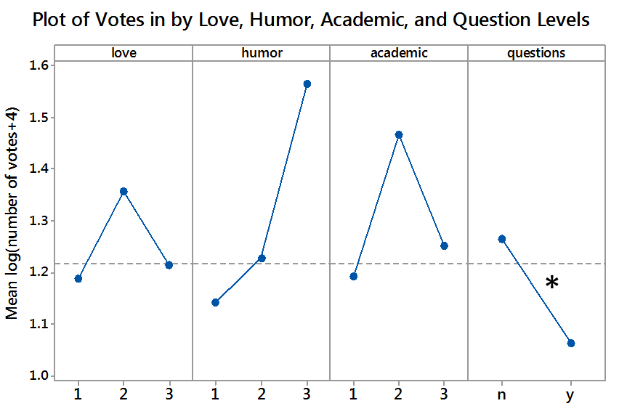

**Figure 2.** Main effects plot of votes given to a post in response to the love, humor, academic, and question scale. “n” denotes not a question and “y” denotes a question. Categories of 1-3 denote academic, humor, and love relevance, 1 being not related and 3 being very related.

**\*** Denotes a significant difference between levels (F=11.6, df=1, p=0.005)

**Discussion**

The results above indicate that we can reject our null hypothesis that there is no difference in the mean number of votes a post received and the question type of the post (F=11.6, df=1, p=0.005). We also found that there is a significant interaction effect between the question type and academic level on the number of votes of a post (F=3.47,df=2 ,p=0.024). This study suggests that these two variables can serve as indicator of popularity.

Our results could have been affected by confounding factors such as the subjective categorical ratings, insufficient qualitative categories, the participation of subjects outside of the desired population, and potentially insufficient data collection times. Limitations of this study also include the duration of the experiment, as data may have been more representative of the population in a longer study. This study may not be able to be utilized at many campuses, as Yik Yak has been banned at various schools due to its controversial and potentially disruptive nature.

The significance of question type on the number of votes a post receives suggests that users only find certain types of posts entertaining. Continuing to examine what types of posts are popular could also lead to further insight into popular culture. As Yik Yak has become increasingly popular on college campuses, it could also be used as a tool to examine a student body’s mental health. Examining the attitudes and topics of posts could allow institutions to understand how students perceive college life and its many challenges.

Further research to determine which characteristics of a post correlate with popularity could include more categories, such as the attitude of the post, number of swear words, and relevance to current events. It would also be interesting to see how the Yik Yak communities vary by demographic and geographic regions; different areas and groups of people might have different preferences for certain types of posts. Despite Yik Yak’s controversial nature, it is a valuable tool in understanding cultural values and social dynamics.

**References:**

DeAmicis, Carmel. February 13, 2015. Yik Yak’s Growth Flatlined After Funding, But Why? Gigaom. https://gigaom.com/2015/02/13/yik-yaks-growth-flatlined-after-fundi ng-but-why/. Accessed May 4th, 2015.

Dewey, Caitlin. October 7th, 2014. How Do You Solve a Problem Like Yik Yak?. The Washington Post. http://www.washingtonpost.com/news/the-intersect/wp/2014/10 /07/how-do-you-solve-a-problem-like-yik-yak/. Accessed May 3rd, 2015.

Valencia, Nick. March 10th, 2014. Yik Yak Chat App Stirring Up Trouble in High Schools. CNN: U.S. Edition.http://www.cnn.com/2014/03/07/tech/yik-yak-app-high-school -problems/. Accessed May 3rd, 2015.